

**Student Name:** Peter Lucan

**Student Number:** C00228946

**Date:** 15/03/2021

**Purpose:** Secure Applications Assignment

Secure Application Development Project 30%

Table of Contents

Table of Figures 4

1 Introduction 6

2 Application Breakdown 6

2.1 Regular User POV 6

2.1 ADMIN POV 10

3 Implementation of the Given Tasks 12

3.1 Auto Creating the Underlying Database 12

3.2 Registering With the System 14

3.3 Logging In ( Unsuccessful Authentication ) 33

3.4 Logging In ( Successful Authentication ) 40

3.5 Password Change 44

3.6 Event Log & ADMIN User 51

4 Security Testing 54

4.1 SignUp.php Testing 54

4.1.1 XSS and SQL Injection Testing 54

4.1.2 Password and Authentication Testing 56

4.1.3 Session Management Testing 58

4.1.1 CSRF Testing 58

4.2 Login.php Testing 58

4.2.1 XSS and SQL Injection Testing 58

4.2.2 Password and Authentication Testing 59

4.2.3 Session Management Testing 60

4.2.4 CSRF Testing 60

4.3 MainMenu.php Testing 60

4.3.1 XSS and SQL Injection Testing 60

4.3.2 Password and Authentication Testing 61

4.3.3 Session Management Testing 62

4.3.4 CSRF Testing 62

4.4 Admin.php Testing 62

4.4.1 XSS and SQL Injection Testing 62

4.4.2 Password and Authentication Testing 62

4.4.3 Session Management Testing 63

4.4.4 CSRF Testing 64

4.5 HomePage.php Testing 64

4.5.1 XSS and SQL Injection Testing 64

4.5.2 Password and Authentication Testing 64

4.5.3 Session Management Testing 65

4.5.4 CSRF Testing 65

4.6 ProfilePage.php Testing 65

4.6.1 XSS and SQL Injection Testing 65

4.6.2 Password and Authentication Testing 66

4.6.3 Session Management Testing 67

4.6.4 CSRF Testing 67

4.7 SecretRecords.php Testing 67

4.7.1 XSS and SQL Injection Testing 67

4.7.2 Password and Authentication Testing 68

4.7.3 Session Management Testing 69

4.7.4 CSRF Testing 69

4.8 ChangePassword.php Testing 69

4.8.1 XSS and SQL Injection Testing 69

4.8.2 Password and Authentication Testing 70

4.8.3 Session Management Testing 71

4.8.4 CSRF Testing 72

4.9 Logout.php Testing 72

4.9.1 XSS and SQL Injection Testing 72

4.9.2 Password and Authentication Testing 73

4.9.3 Session Management Testing 73

4.9.4 CSRF Testing 73

5 Conclusion 73

# Table of Figures

**Figure 1:** Screenshot of the Sign-Up Page. 6

**Figure 2:** Screenshot of the Login Page. 7

**Figure 3:** Screenshot of the Main Menu. 7

**Figure 4:** Screenshot of the Home Page. 8

**Figure 5:** Screenshot of the Profile Page. 8

**Figure 6:** Screenshot of the Change Password Page. 9

**Figure 7:** Screenshot of the Locked Page. 9

**Figure 8:** Screenshot of the Login Page. 10

**Figure 9:** Screenshot of the Main Menu for the ADMIN. 10

**Figure 10:** Screenshot of the Admin Page which contains the Event Log. 11

**Figure 11:** Screenshot of the Secret Records Page. 11

**Figure 12:** Screenshot of db.include.php Part 1. 12

**Figure 13:** Screenshot of db.include.php Part 2. 13

**Figure 14:** Screenshot of db.include.php Part 3. 14

**Figure 15:** The Database Created. 14

**Figure 16:** The users Table Created. 14

**Figure 17:** The admin Table Created. 14

**Figure 18:** Screenshot of the Task From the Specification. 14

**Figure 19:** Screenshot of the Sign-Up Page. 15

**Figure 20:** Screenshot of the Sign-Up Page With the Username Already Taken. 16

**Figure 21:** Sign-Up Page With Empty Fields 17

**Figure 22:** Sign-Up Page where the Passwords Do Not Match. 18

**Figure 23:** Sign-Up Attempt When Password is Less Than 8 Characters. 19

**Figure 24:** Sign-Up Attempt When The Password Does Not Contain a Upper-Case Character. 20

**Figure 25:** Sign-Up Attempt When The Password Does Not Contain a Lower-Case Character. 21

**Figure 26:** Sign-Up Attempt When the Password Contains No Number. 22

**Figure 27:** Sign-Up Attempt When the Password Contains No Special Characters. 23

**Figure 28:** Sign-Up Page With the Passwords Shown. 24

**Figure 29:** Part One of the Utility.php File. 25

**Figure 30:** Part One of the Utility.php File. 25

**Figure 31:** Function.js File Containing The Show Password Functions. 26

**Figure 32:** SignUp.php Part 1. 27

**Figure 33:** SignUp.php Part 2. 28

**Figure 34:** SignUp.php Part 3. 28

**Figure 35:** SignUp.php Part 4. 29

**Figure 36:** SignUp.php Part 5. 29

**Figure 37:** SignUp.php Part 6. 30

**Figure 38:** SignUp.php Part 7. 30

**Figure 39:** SignUp.php Part 8. 31

**Figure 40:** SignUp.php Part 9. 31

**Figure 41:** SignUp.php Part 10. 32

**Figure 42:** SignUp.php Part 11. 32

**Figure 43:** Screenshot of the Task From the Specification. 33

**Figure 44:** The Login Page. 33

**Figure 45:** Login Attempt With No Username or Password Entered. 34

**Figure 46:** Login With Invalid Credentials. 35

**Figure 47:** The Locked Page. 35

**Figure 48:** LockedPage.php Part One. 36

**Figure 49:** LockedPage.php Part Two. 37

**Figure 50:** Login.php Part 1. 37

**Figure 51:** Login.php Part 2. 37

**Figure 52:** Login.php Part 3. 38

**Figure 53:** Login.php Part 4. 38

**Figure 54:** Login.php Part 5. 39

**Figure 55:** Login.php Part 6. 39

**Figure 56:** Login.php Part 7. 40

**Figure 57:** Screenshot of the Task From the Specification. 40

**Figure 58:** Upon Logging Into the Application. 41

**Figure 59:** SessionTime.php 41

**Figure 60:** MainMenu.php Part 1. 42

**Figure 61:** MainMenu.php Part 2. 42

**Figure 62:** MainMenu.php Part 3. 43

**Figure 63:** MainMenu.php Part 4. 44

**Figure 64:** Screenshot of the Task From the Specification. 44

**Figure 65:** Change Password Screen. 45

**Figure 66:** CSRF.php File. 46

**Figure 67:** ChangePassword.php File Part 1. 46

**Figure 68:** ChangePassword.php File Part 2. 47

**Figure 69:** ChangePassword.php File Part 3. 47

**Figure 70:** ChangePassword.php File Part 4. 48

**Figure 71:** ChangePassword.php File Part 5. 48

**Figure 72:** ChangePassword.php File Part 6. 49

**Figure 73:** ChangePassword.php File Part 7. 49

**Figure 74:** ChangePassword.php File Part 8. 50

**Figure 75:** ChangePassword.php File Part 9. 50

**Figure 76:** ChangePassword.php File Part 10. 51

**Figure 77:** Screenshot of the Task From the Specification. 51

**Figure 78:** The Event Log. 52

**Figure 79:** The Event Log. 52

**Figure 80:** The Event Log. 53

**Figure 81:** Example of Inserting Event Information Into the admin Database. 53

**Figure 82:** AdminPage.php Part 1. 53

**Figure 83:** AdminPage.php Part 2. 54

**Figure 84:** AdminPage.php Part 3. 54

# 1 Introduction

In this Secure Applications Development Project, a Secure Web Application was built according to the specification provided with some added CSS to make it visually appealing. This report outlines how the given tasks in this assignment were completed accompanied by relevant source code snippets and GUI Screenshots but first it begins by giving a breakdown of the actual web application.

The final Section of the report presents a series of test cases which were conducted on this web application. These test cases are security test cases and highlight what security features were assessed, the vulnerability type that was tested for, the tests that were performed and finally the results produced by these tests.

# 2 Application Breakdown

This section briefly breaks down and gives a walk through of the Web Application that was produced for this assignment from the point of both the ADMIN and a Regular User.

## 2.1 Regular User POV

First a regular user must sign up for the web application in order to be able to log in. The user can do this via clicking the sign-up link on the login page or by manually inputting the http address of the Sign-Up Page.

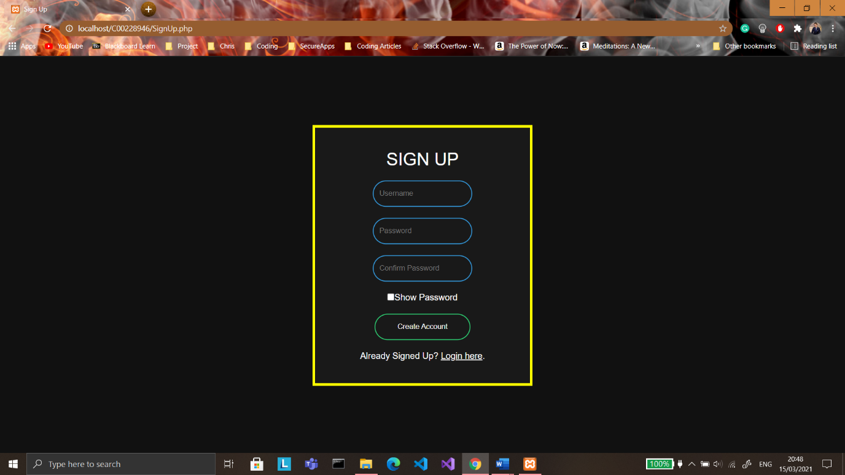

**Figure 1:** Screenshot of the Sign-Up Page.

After Creating and Account the user is redirected to the Login page where they can Login using their credentials to their newly created account.



**Figure 2:** Screenshot of the Login Page.

Upon Successful Login the user is brought to the main menu where they can navigate to different pages of the web application using the nav bar on the top left of the screen or using the menu buttons on the center of the screen that come to life when they are hovered over.

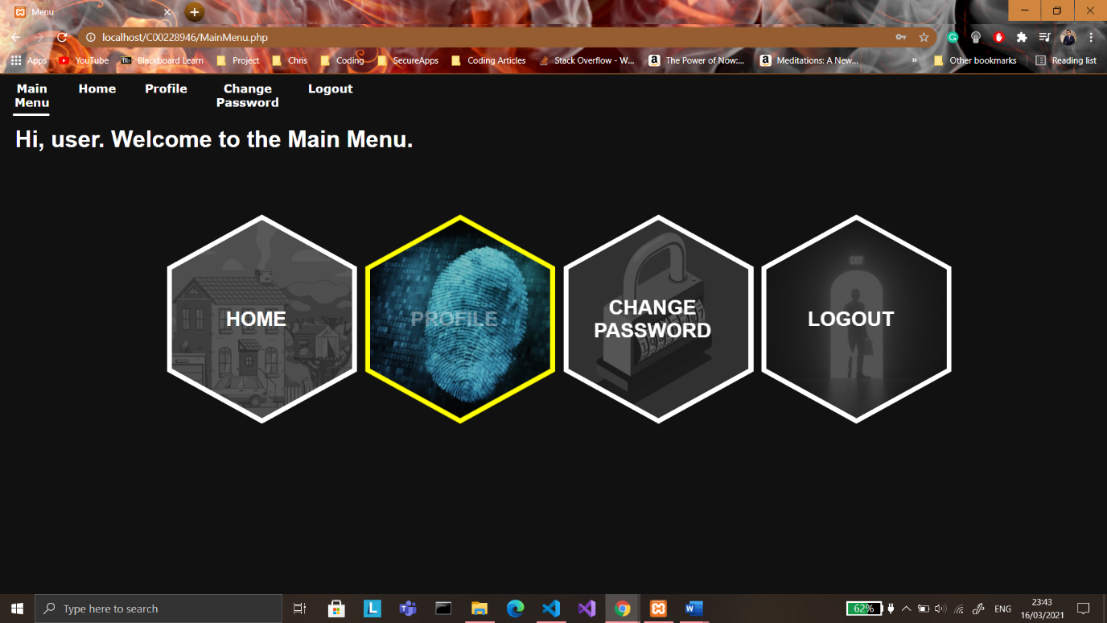

**Figure 3:** Screenshot of the Main Menu.

Within the web application a logged in user can navigate to the Home Page.

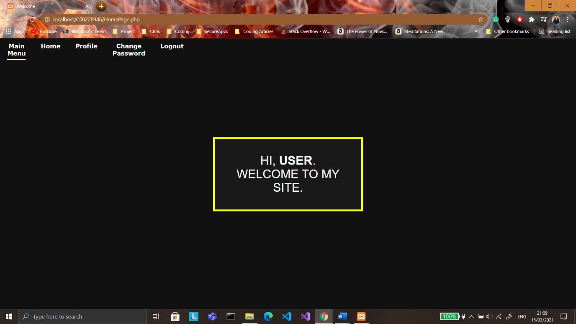

**Figure 4:** Screenshot of the Home Page.

Within the web application a logged in user can also navigate to the Profile Page.

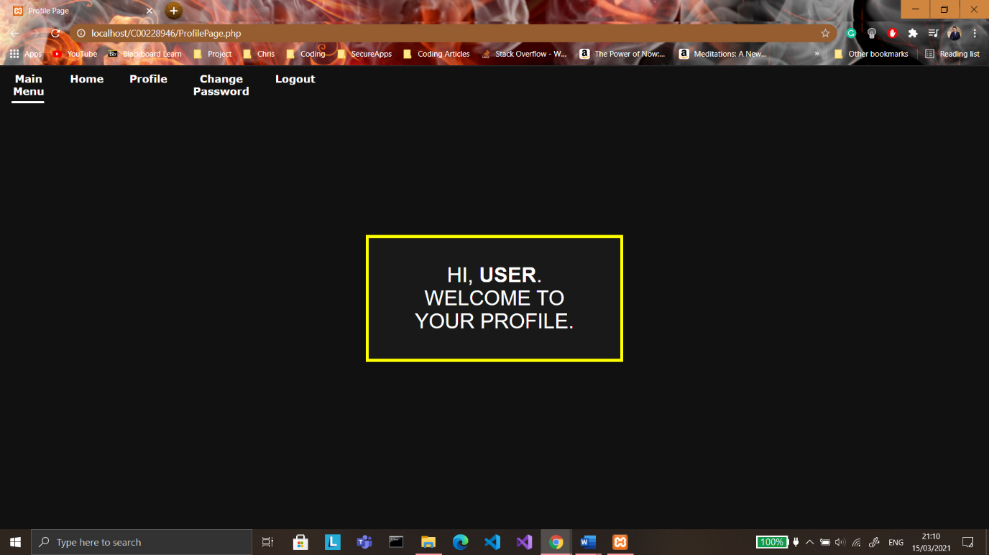

**Figure 5:** Screenshot of the Profile Page.

Within the web application a logged in user can also navigate to the Change Password Page or choose the logout option. Both of these sites log the user out and redirect the user to the login page. On the change password page, the user is logged out once they change their password and if the user presses logout, they are logged out instantly and redirected to the login page.

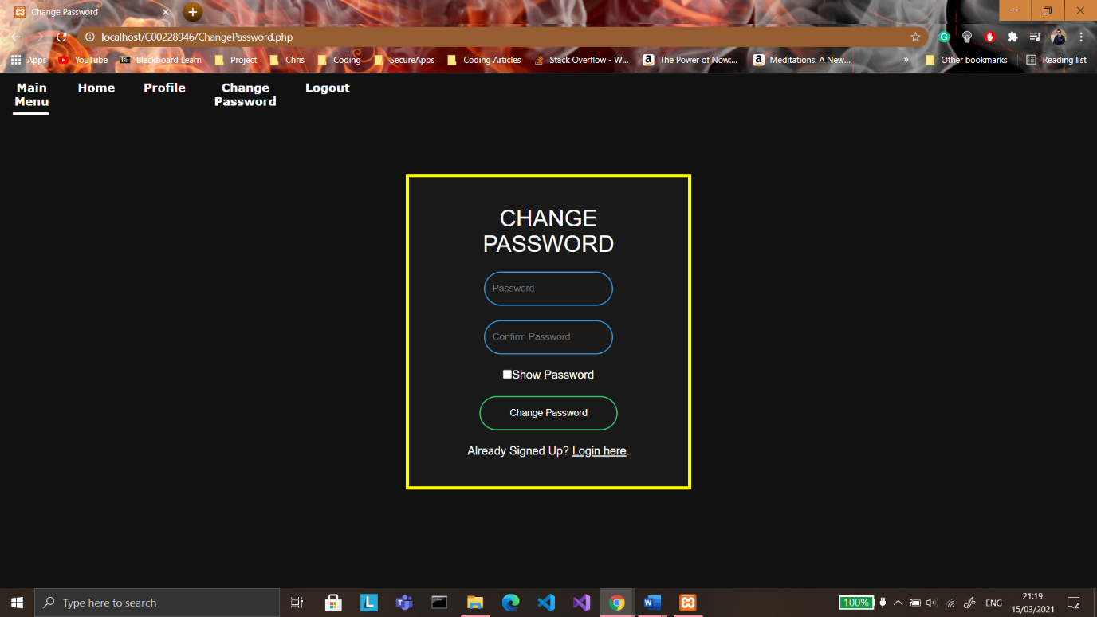

**Figure 6:** Screenshot of the Change Password Page.

On an additional note. If the user fails to log in 5 times in a row. On the 5th failed attempt the user is logged out for 3 mins and brought to the Locked Page. If the user tries to access the application in any way before the 3 minutes are up, they are redirected to the Locked Page.

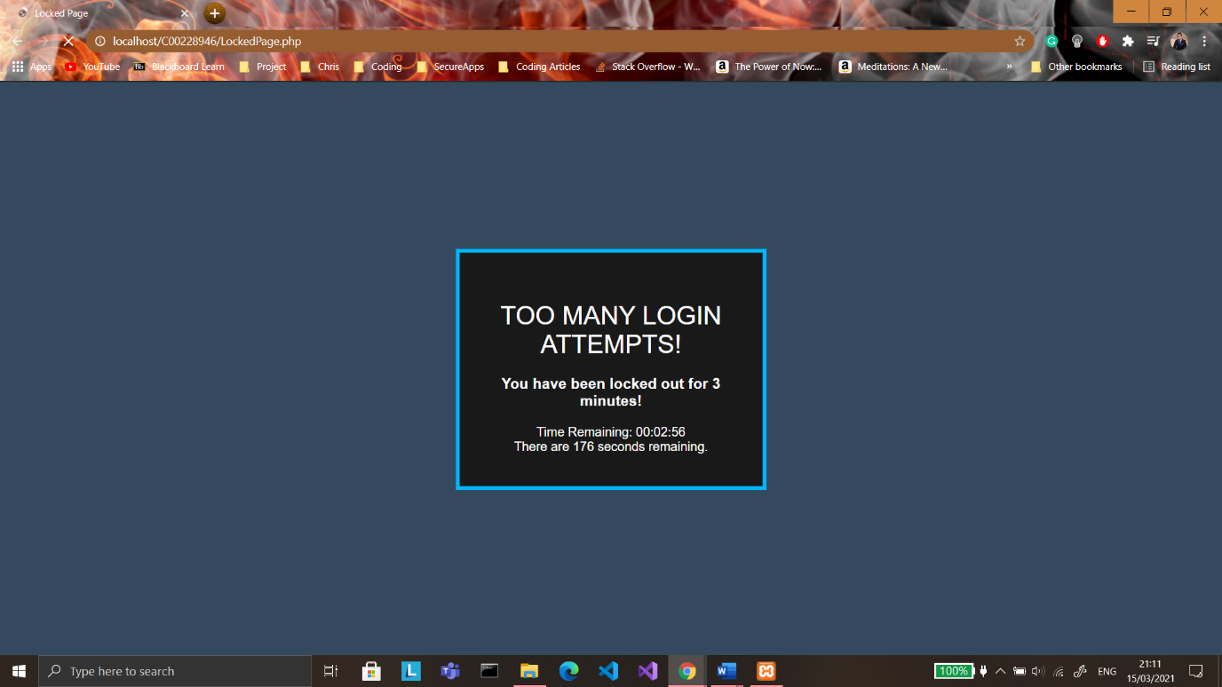

**Figure 7:** Screenshot of the Locked Page.

## 2.1 ADMIN POV

In the case of the ADMIN, they do not have to sign up as their credentials are created and stored in the database when the underlying database is created once any page is loaded and it does not already exist. The ADMIN just has to sign in using the username: “ADMIN” and the password: “SAD_2021!”.

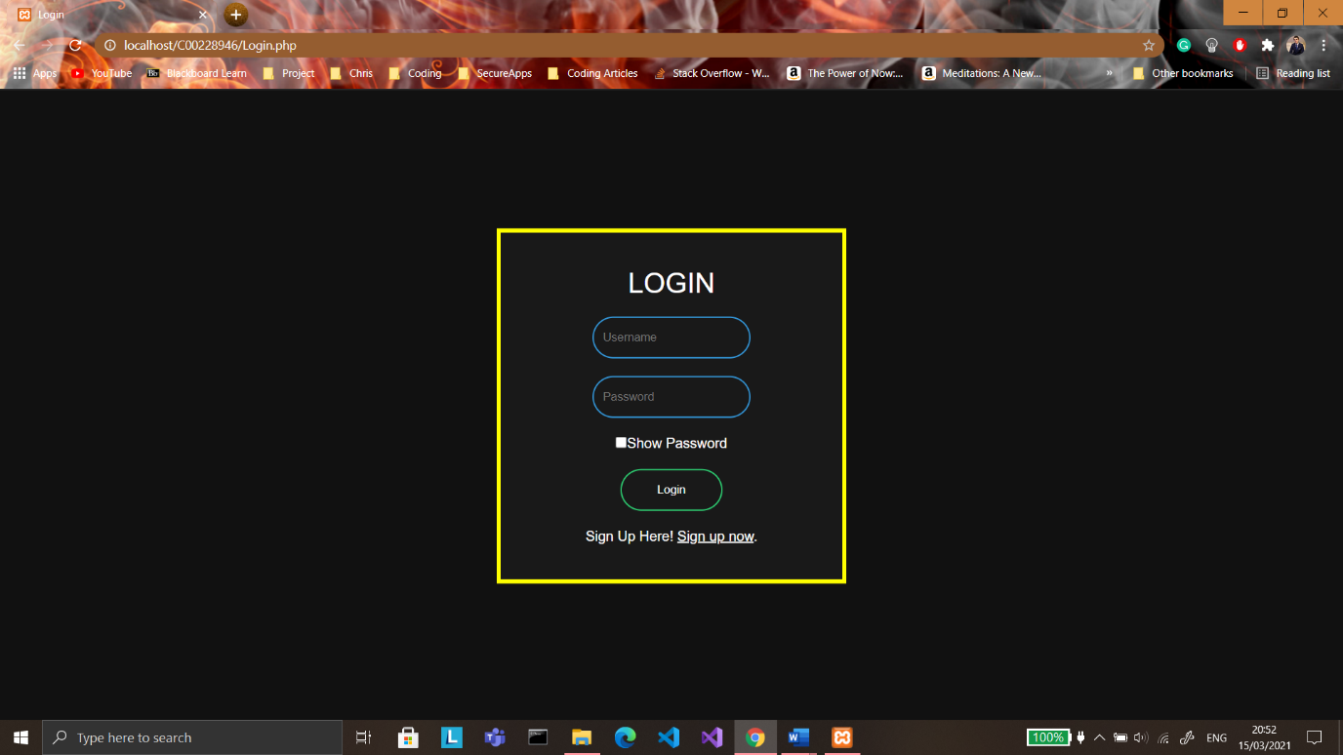

**Figure 8:** Screenshot of the Login Page.

Upon logging in as the ADMIN the main menu page displays a different main menu and a navigation bar with additional pages. This is because the ADMIN has additional access to pages that the regular user does not.

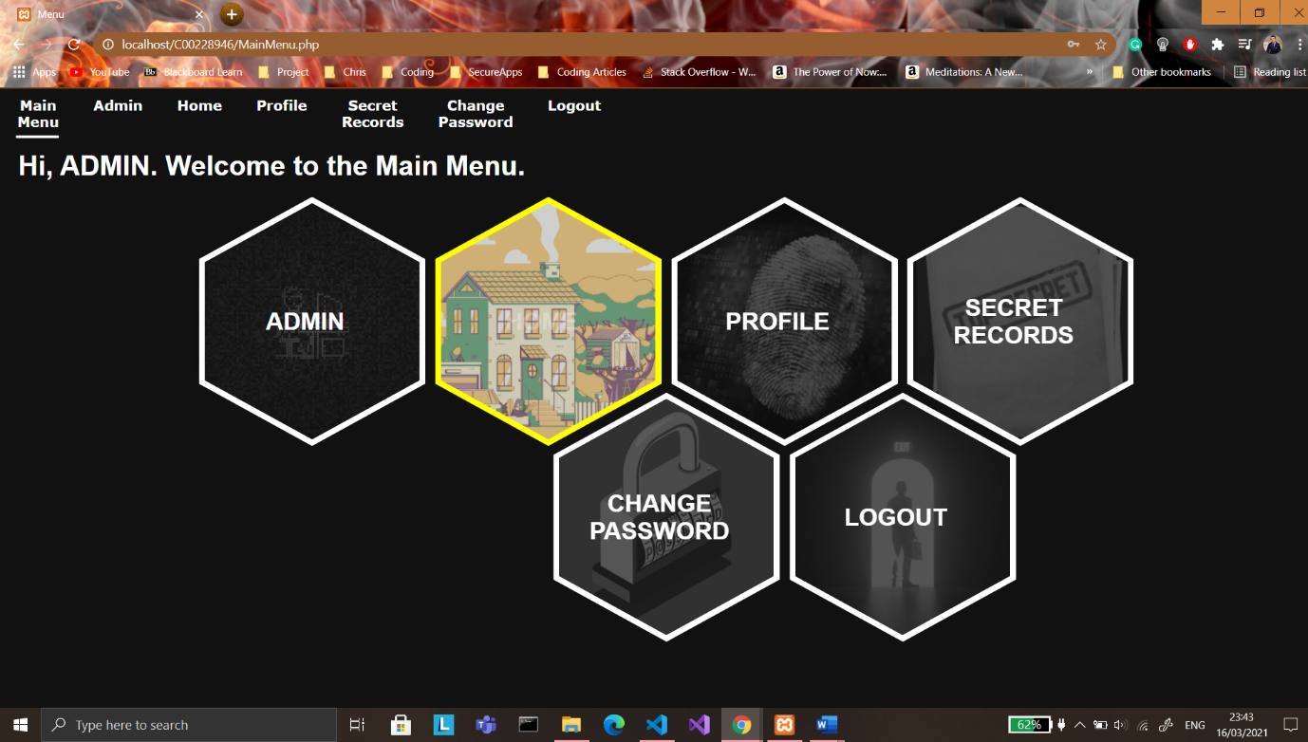

**Figure 9:** Screenshot of the Main Menu for the ADMIN.

The ADMIN has access to the same pages as the regular user plus two more pages which one of is the Admin Page which contains the Event Log which is displayed in a table surrounded by a color changing background.

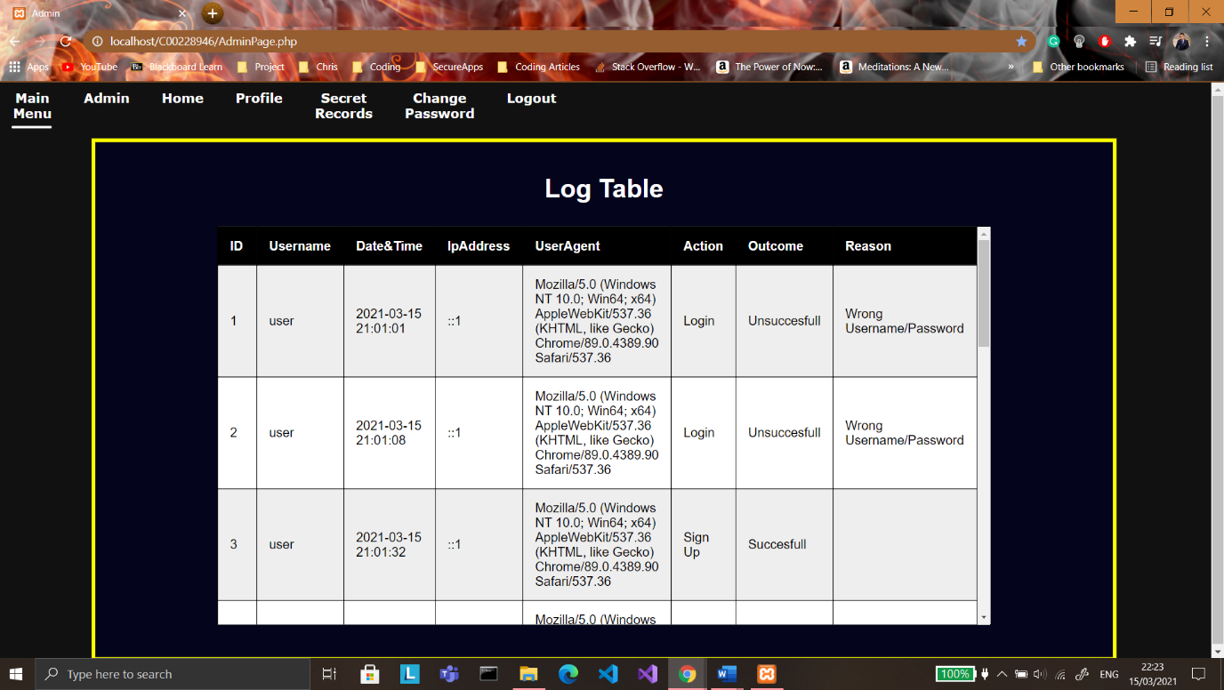

**Figure 10:** Screenshot of the Admin Page which contains the Event Log.

The other additional page that the ADMIN has access to and the regular users do not is the Secret Records page.

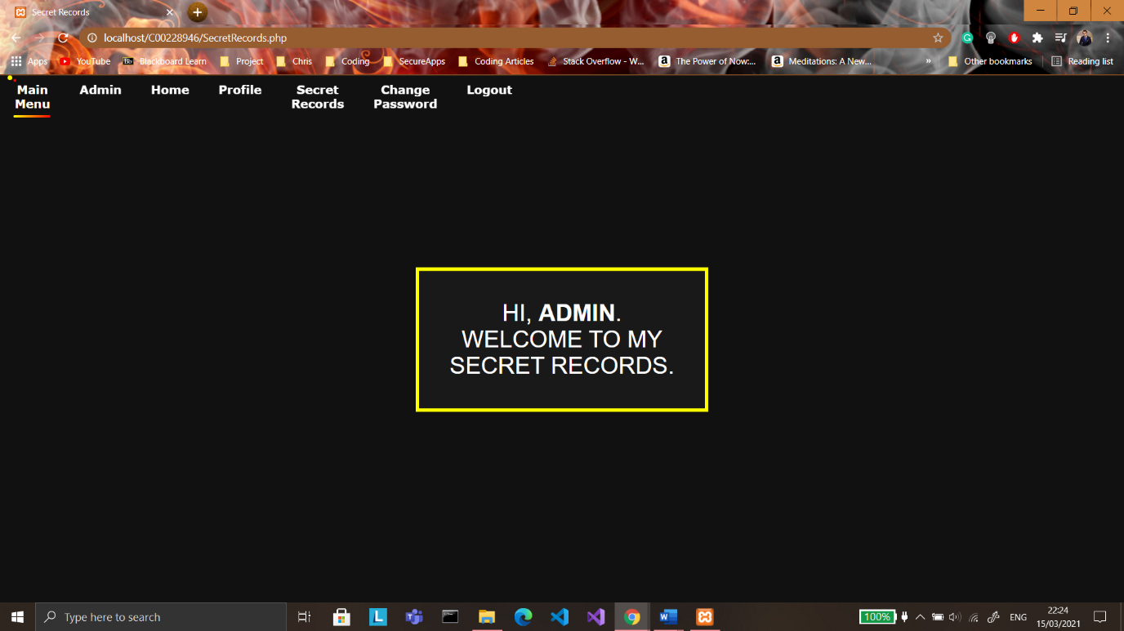

**Figure 11:** Screenshot of the Secret Records Page.

# 3 Implementation of the Given Tasks

This section covers how the tasks from the specification for this project were implemented with accompanying screenshots.

## 3.1 Auto Creating the Underlying Database

For this application to work on other computers the underlying database had to be created on requesting any page as the root user with no password. This means that the database had to be created automatically, the required tables had to be created automatically and also filled in with the relevant data when the application was loaded for the first time. The database and the tables are only created if they do not already exist and the data is only inserted if it does not already exist also. This was done by writing the db.include.php file and then calling it at the top of Login and Sign-Up pages with the include command. There is no need to include this file in other files as they all redirect to the Login page if the user is not logged in. The code for this can be viewed in the screenshots bellow and is explained thoroughly with comments in the code so it does not need further explanation using text in this document.

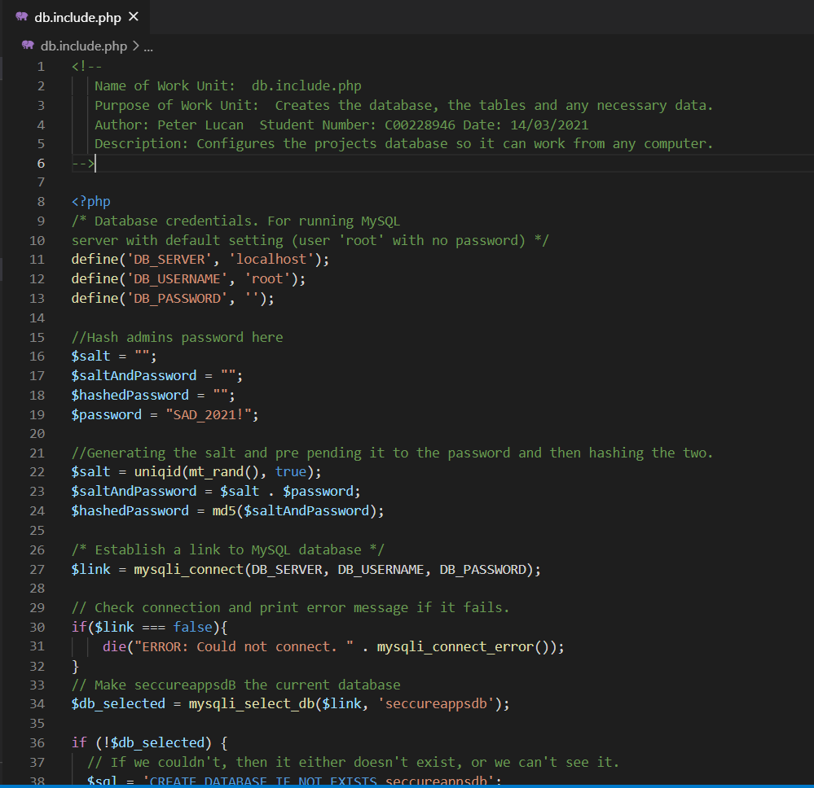

**Figure 12:** Screenshot of db.include.php Part 1.

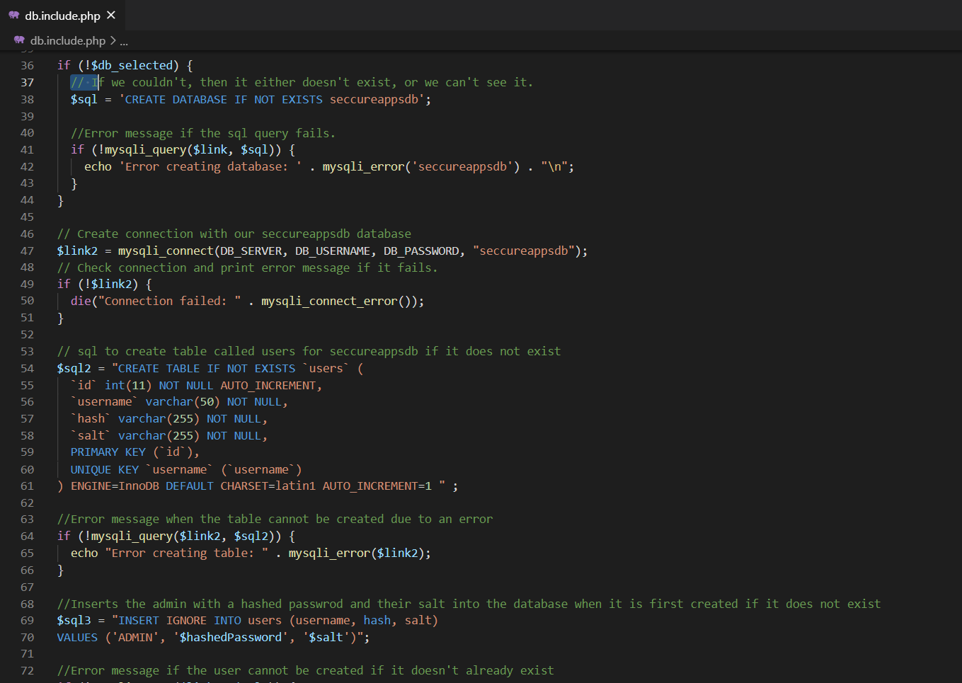

**Figure 13:** Screenshot of db.include.php Part 2.

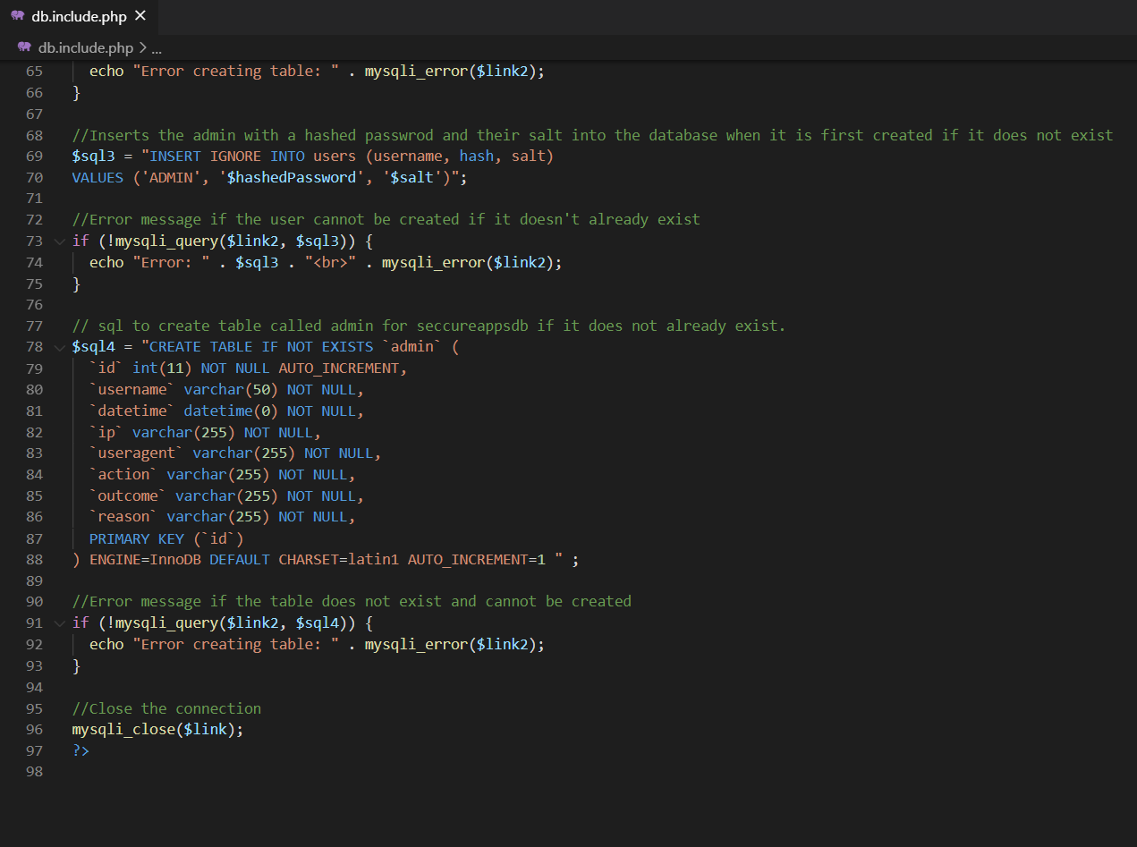

**Figure 14:** Screenshot of db.include.php Part 3.

The code above creates the following database with the following tables.

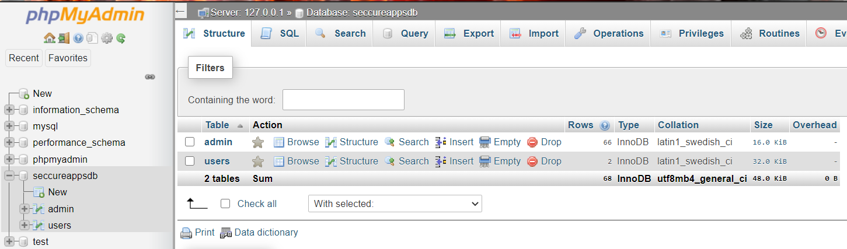

**Figure 15:** The Database Created.

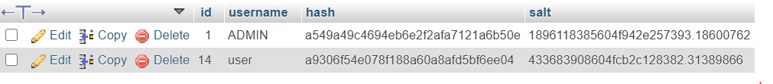

**Figure 16:** The users Table Created.

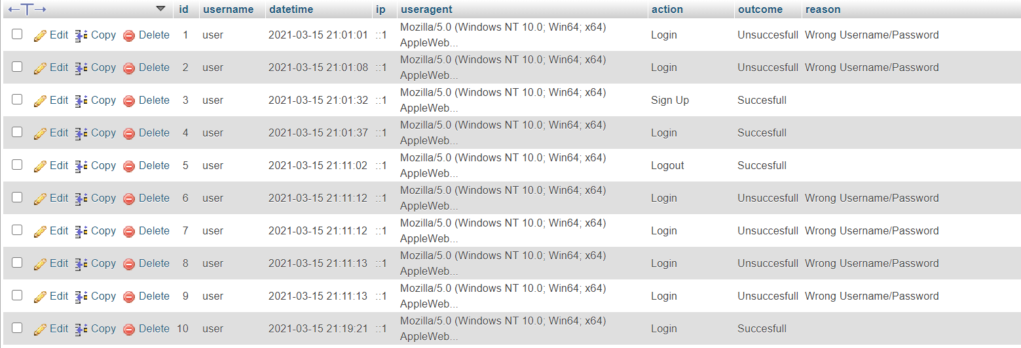

**Figure 17:** The admin Table Created.

## 3.2 Registering With the System

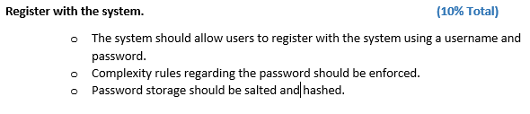

**Figure 18:** Screenshot of the Task From the Specification.

A regular user can register with the system using the SignUp.php page. The user must enter a username and then enter a password and confirm their password and click the Create Account Button.

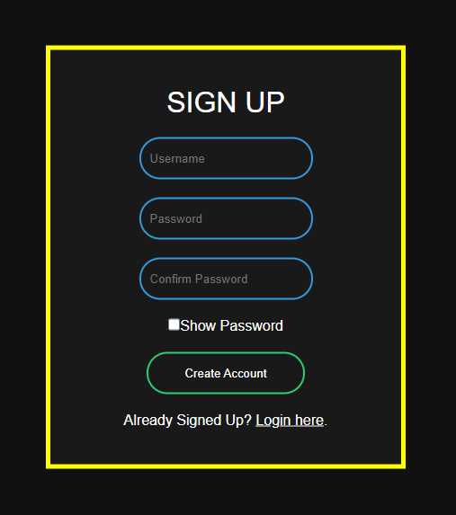

**Figure 19:** Screenshot of the Sign-Up Page.

The system does not accept duplicate usernames regardless of what case they are in and displays an error message to the user if they try to make an account with a username that is already taken.

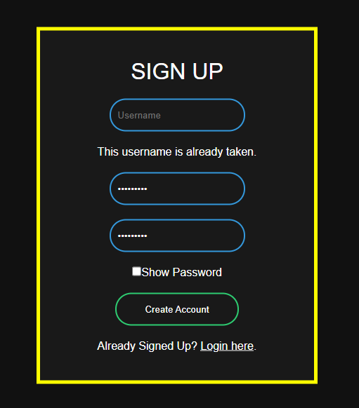

**Figure 20:** Screenshot of the Sign-Up Page With the Username Already Taken.

The user also cannot leave any of the fields empty and the system displays error messages if this is the case.

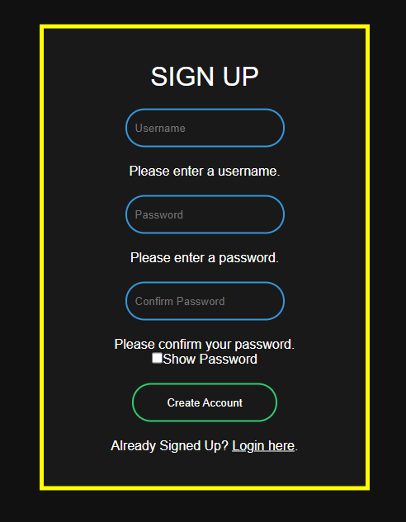

**Figure 21:** Sign-Up Page With Empty Fields

The user also has to put in the same password in both the password field and the confirm password field otherwise the system outputs an error message.

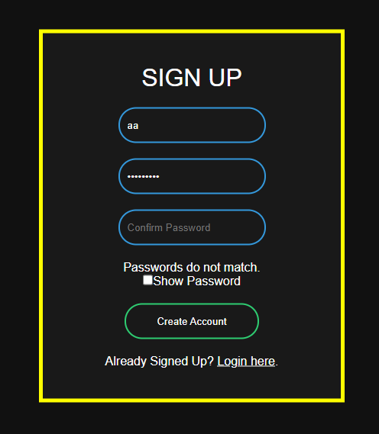

**Figure 22:** Sign-Up Page where the Passwords Do Not Match.

The system also enforces password complexity rules and only accepts a password that is at least 8 characters in length, contains at least one upper case character, contains at least one lower case character, contains at least one number and also contains at least on special character. The system prints the following error messages for when these conditions are not met.

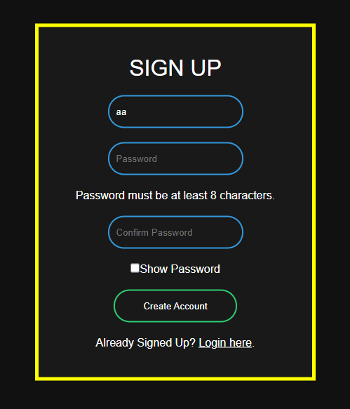

**Figure 23:** Sign-Up Attempt When Password is Less Than 8 Characters.

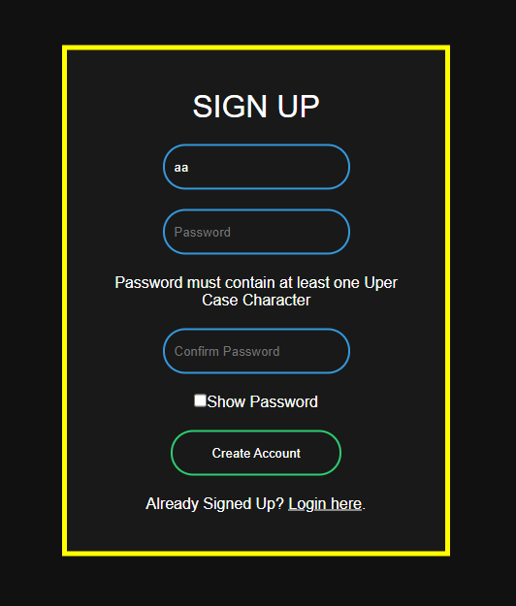

**Figure 24:** Sign-Up Attempt When The Password Does Not Contain a Upper-Case Character.

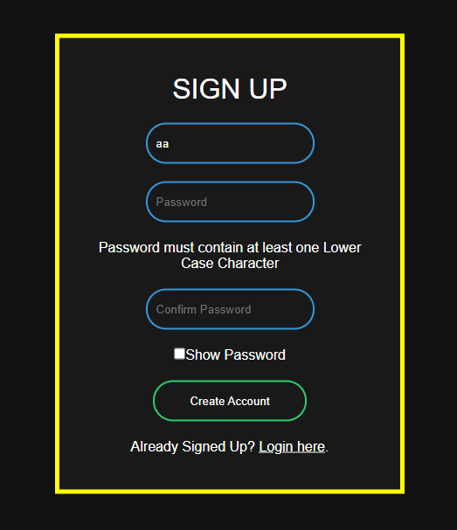

**Figure 25:** Sign-Up Attempt When The Password Does Not Contain a Lower-Case Character.

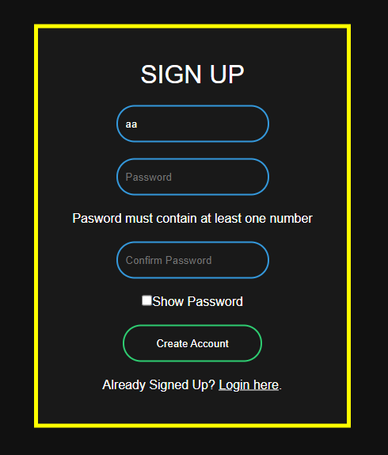

**Figure 26:** Sign-Up Attempt When the Password Contains No Number.

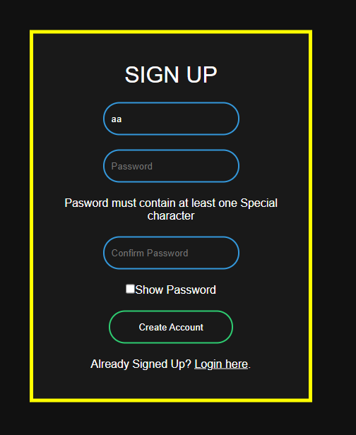

**Figure 27:** Sign-Up Attempt When the Password Contains No Special Characters.

The user can also check the checkbox to view the passwords they are entering.

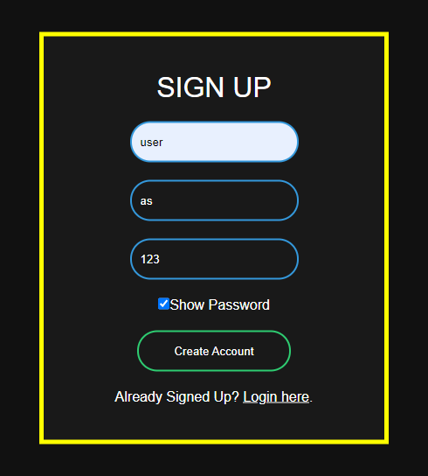

**Figure 28:** Sign-Up Page With the Passwords Shown.

On successful signup the user is brought to the login page and the passwords is processed by prepending a unique salt and then hashing that salt and password. The salt and the hashed password are then stored in the database. The way the password is stored in the database can be viewed in the below.

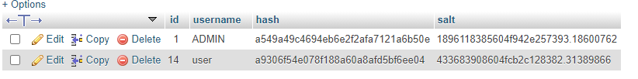

**Figure 26:** The Way the Passwords are Stored in the Database.

The code for how this was achieved can be viewed in the screenshots bellow and is explained thoroughly with comments in the code so it does not need further explanation using text in this document. The signup page includes the aforementioned db.include.php file and the Utility.php file and the majority of its code is written in the SignUp.php file. It also calls the Functions.js file and uses the Style2.css file.

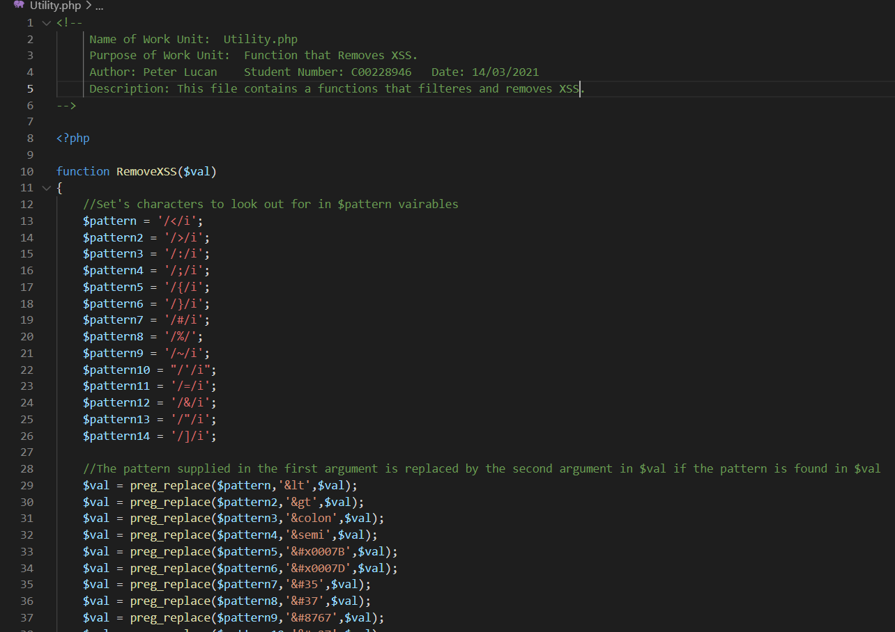

**Figure 29:** Part One of the Utility.php File.

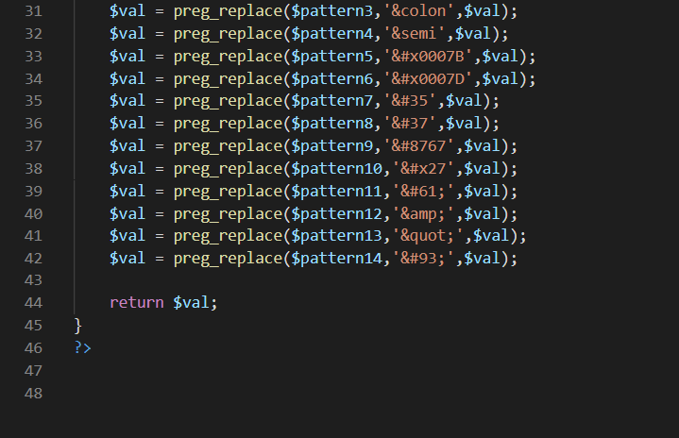

**Figure 30:** Part One of the Utility.php File.

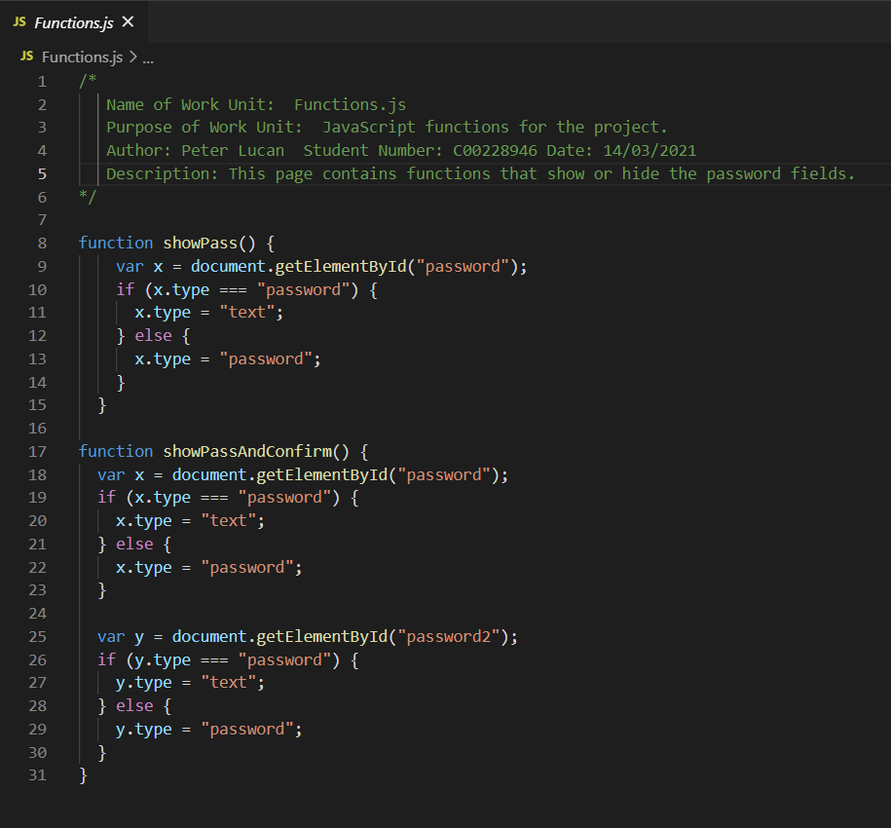

**Figure 31:** Function.js File Containing The Show Password Functions.

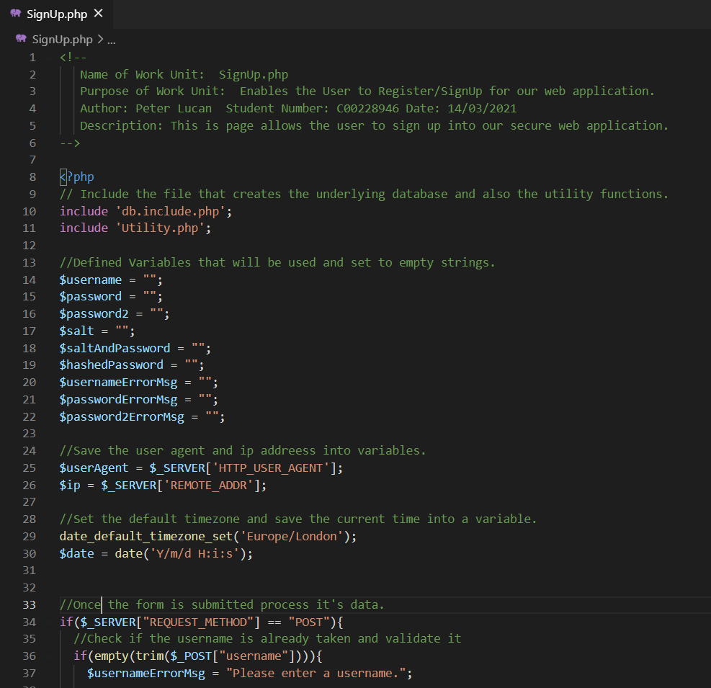

**Figure 32:** SignUp.php Part 1.

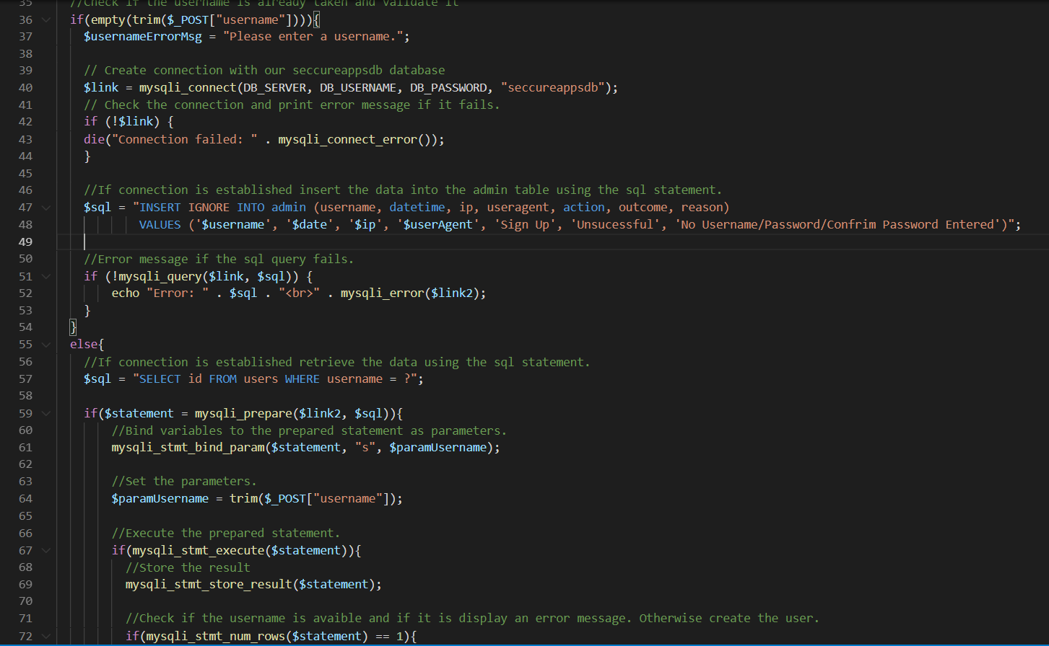

**Figure 33:** SignUp.php Part 2.

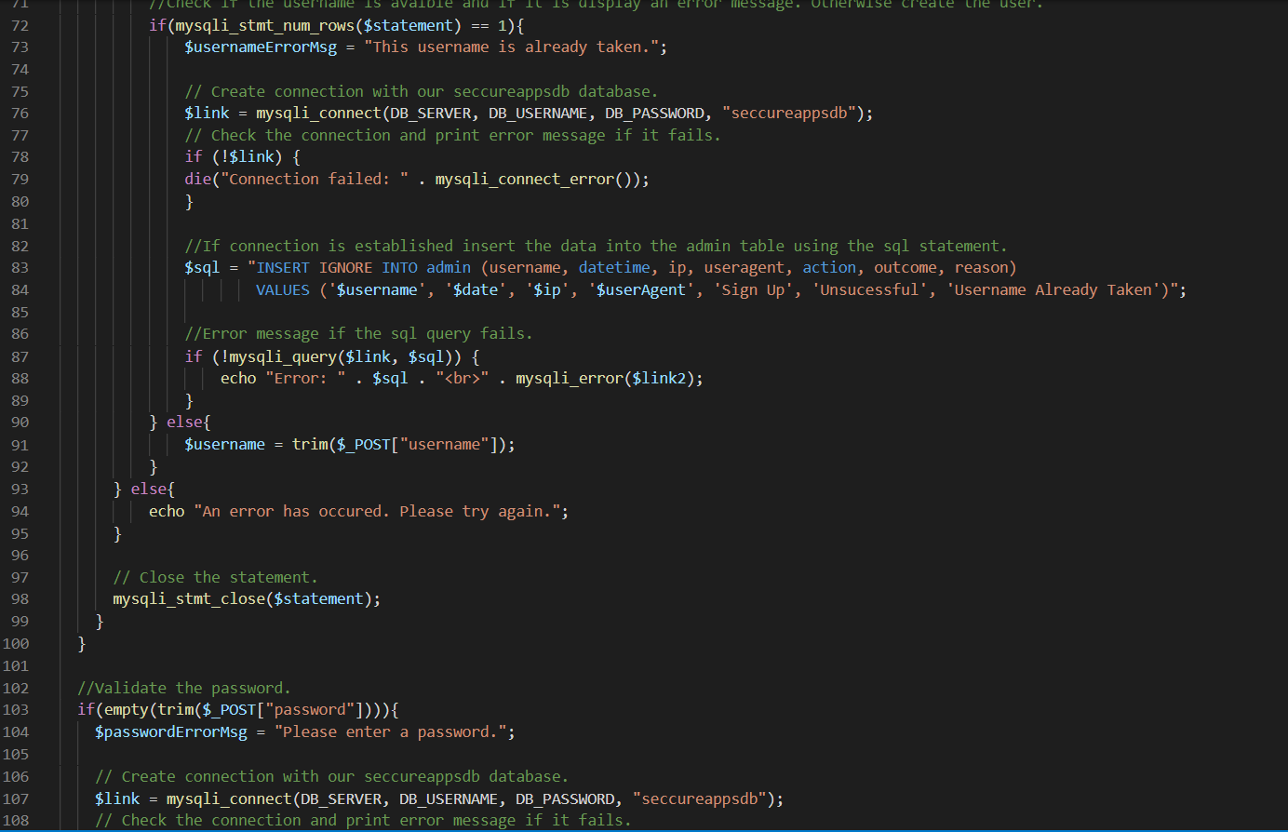

**Figure 34:** SignUp.php Part 3.

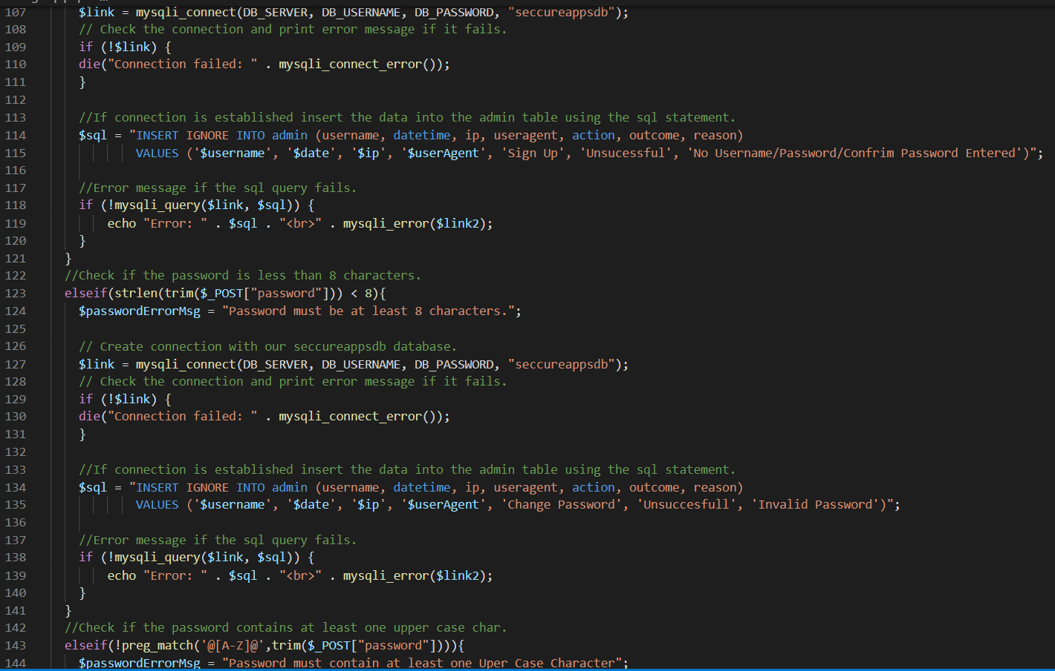

**Figure 35:** SignUp.php Part 4.

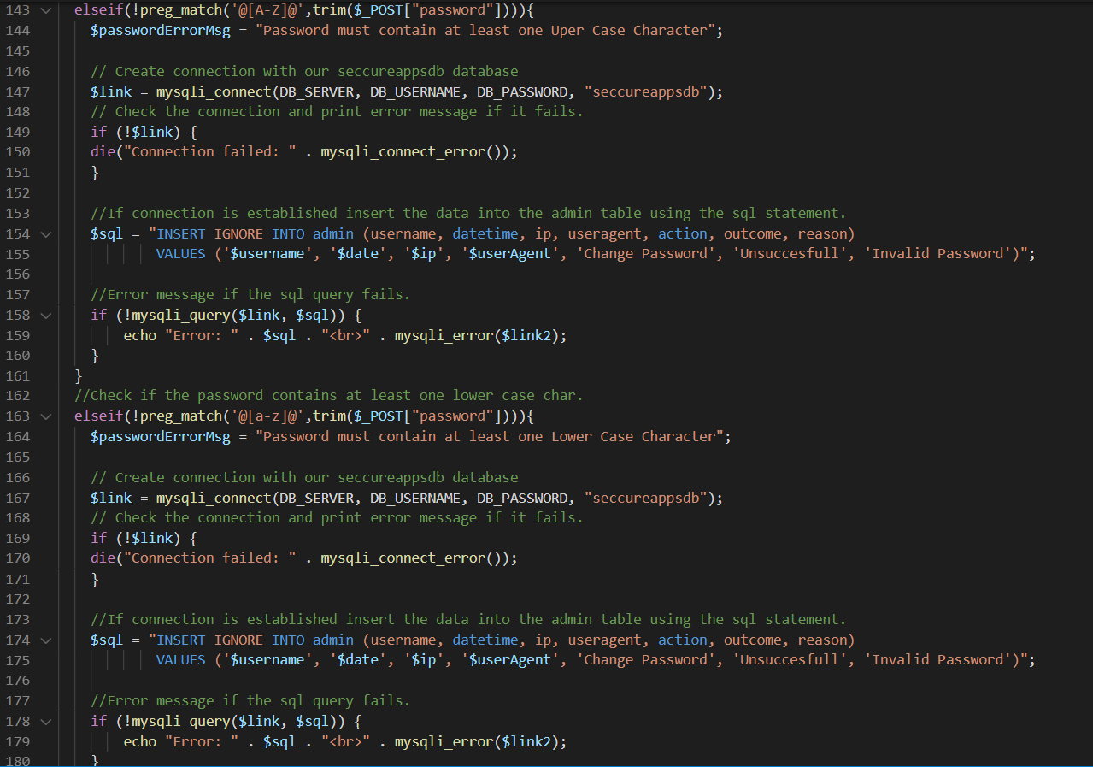

**Figure 36:** SignUp.php Part 5.

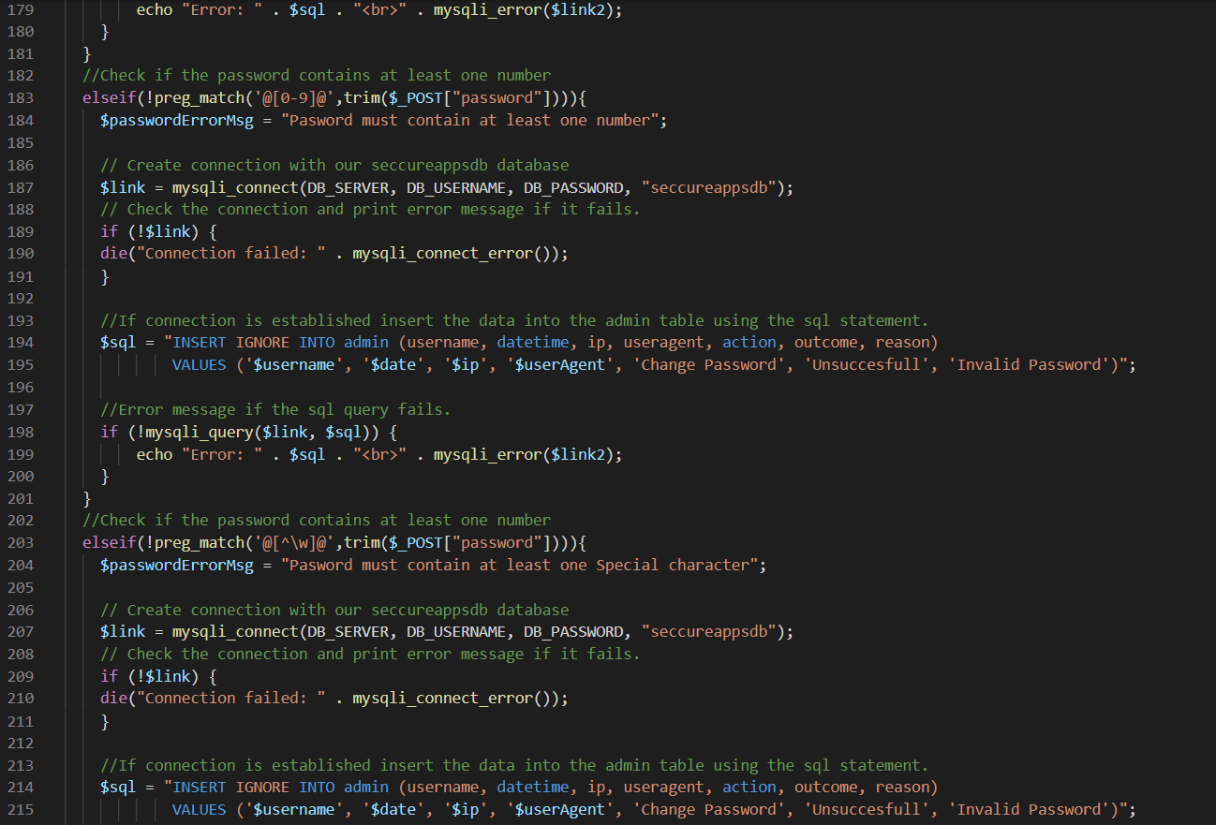

**Figure 37:** SignUp.php Part 6.

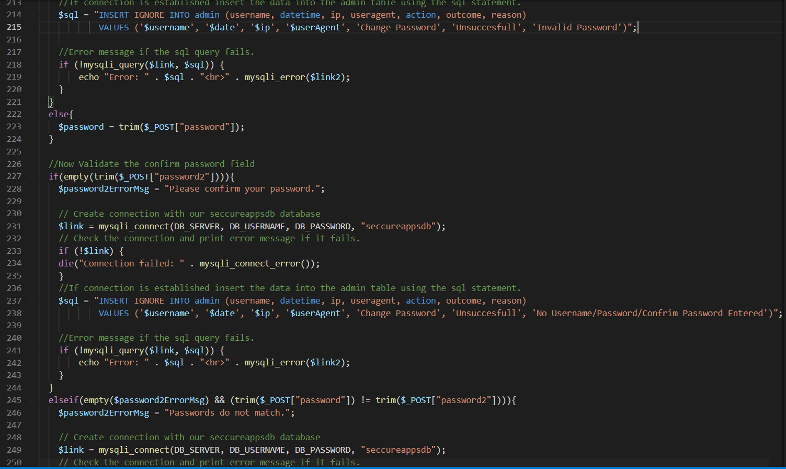

**Figure 38:** SignUp.php Part 7.

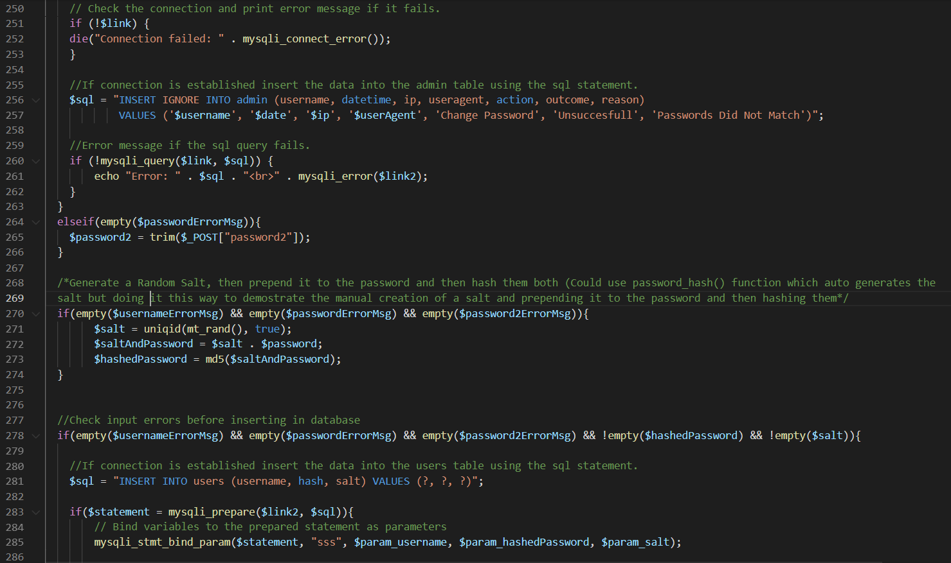

**Figure 39:** SignUp.php Part 8.

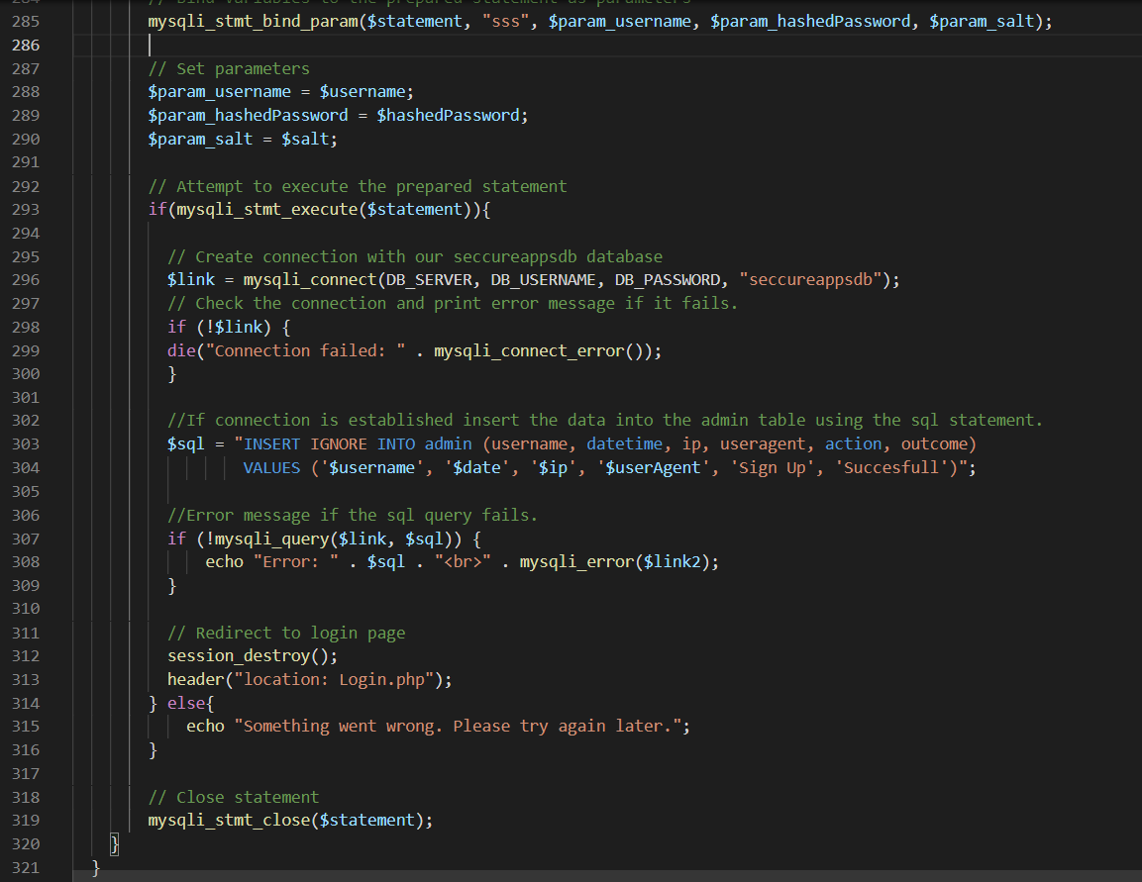

**Figure 40:** SignUp.php Part 9.

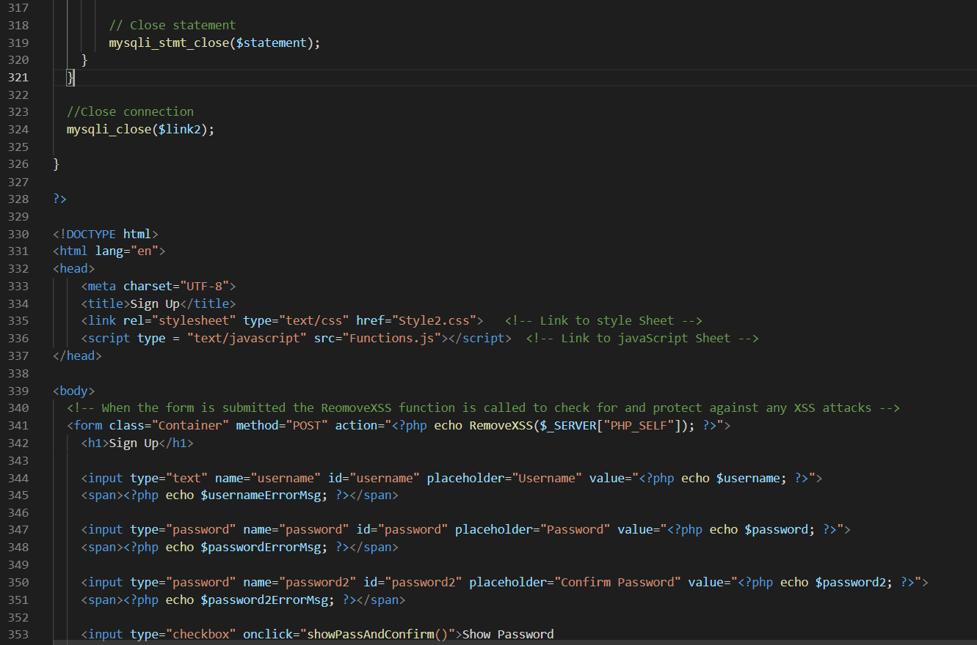

**Figure 41:** SignUp.php Part 10.

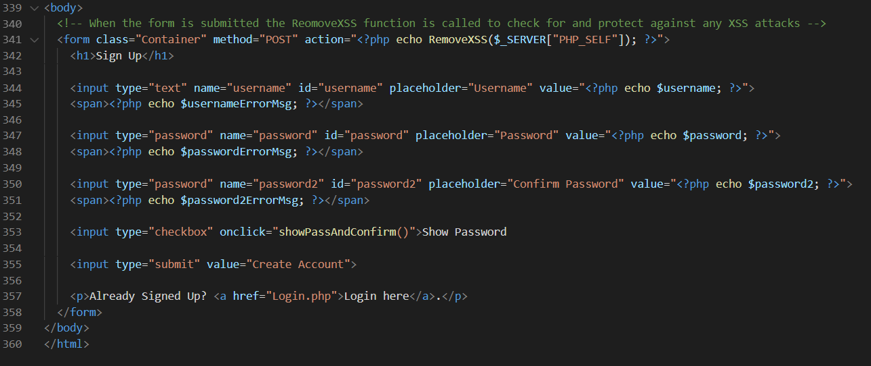

**Figure 42:** SignUp.php Part 11.

## 3.3 Logging In ( Unsuccessful Authentication )

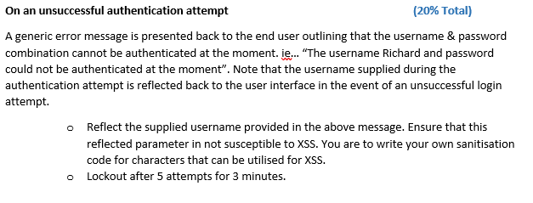

**Figure 43:** Screenshot of the Task From the Specification.

Both the Admin and a regular user can log into the application using the login page. Once again like on the Sign-up page they can also view the password using the show password checkbox.

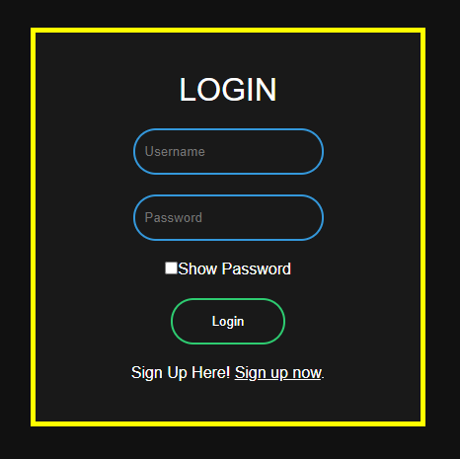

**Figure 44:** The Login Page.

If the user tries to log in without entering a username or a password or both the system asks them to please enter a username and/or please enter a password.

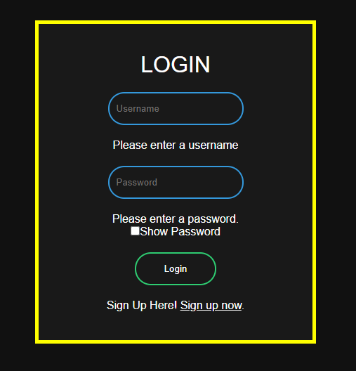

**Figure 45:** Login Attempt With No Username or Password Entered.

If the user enters incorrect credentials the user is met with a generic error message that reflects the username but not the password back to the UI. This error message is displayed below.

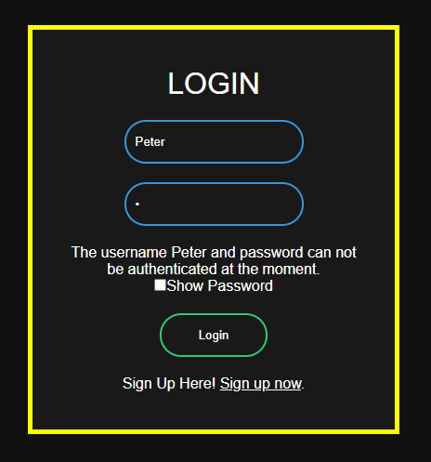

**Figure 46:** Login With Invalid Credentials.

If the user enters the wrong credentials 5 times in a row the user is locked out of the page for 3 mins and is redirected to the Locked Page. The user cannot access any other page of this web application until the 3 minutes are up and if they try to, they are redirected to the Locked Page.

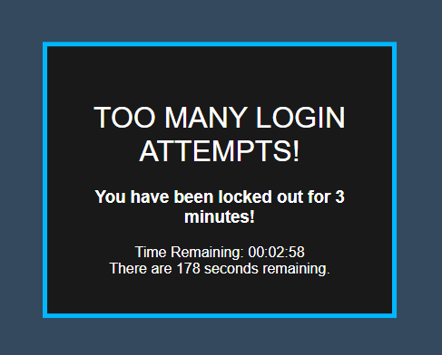

**Figure 47:** The Locked Page.

The code for how this was achieved can be viewed in the screenshots bellow and is explained thoroughly with comments in the code so it does not need further explanation using text in this document. The signup page includes the aforementioned db.include.php file,links the Style2.css file, the Utility.php file, the Functions.js file and the majority of its code is written in the Login.php file. It also redirects to the LockedPage.php file which is styled using the Style.css file.

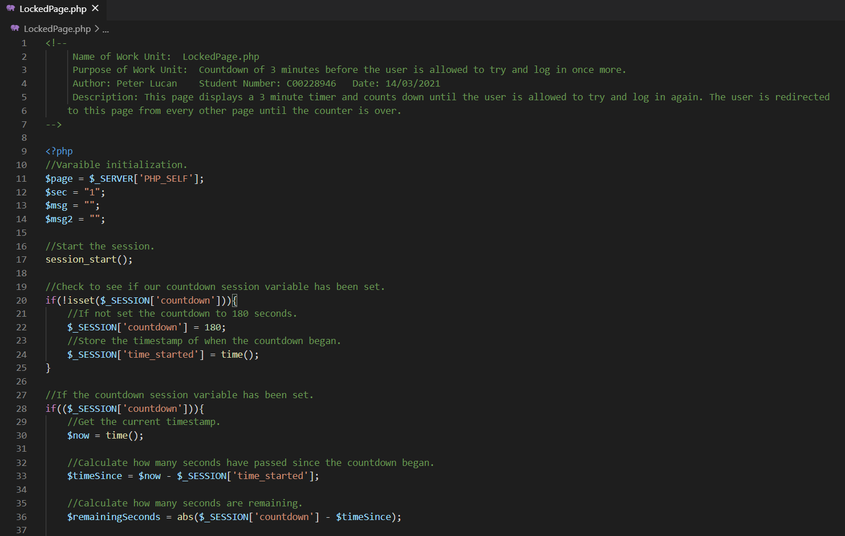

**Figure 48:** LockedPage.php Part One.

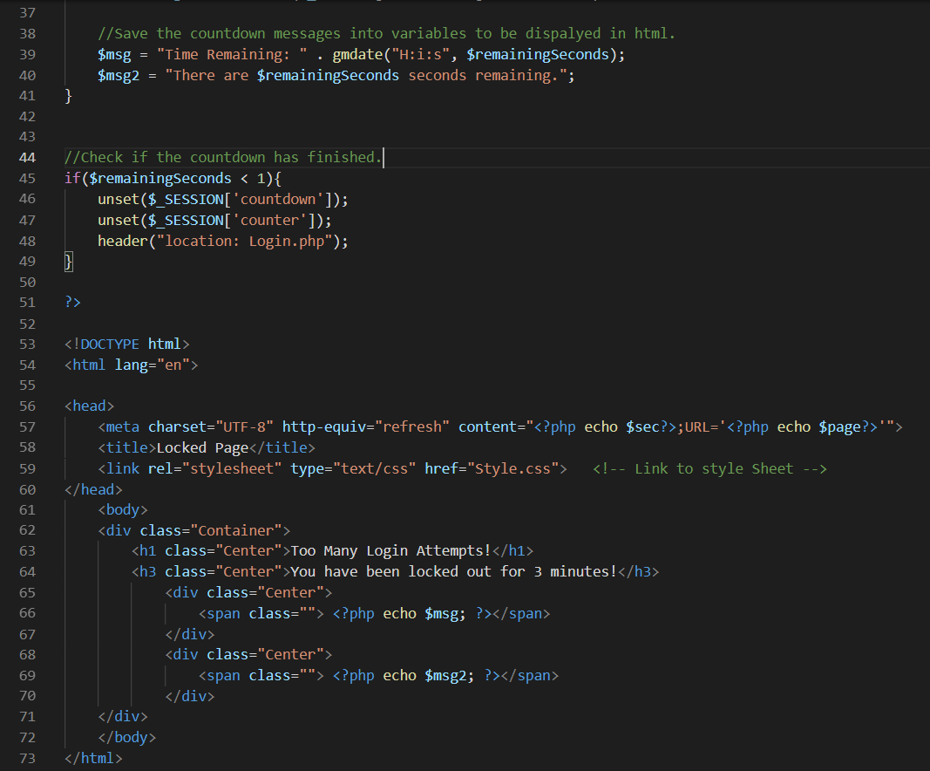

**Figure 49:** LockedPage.php Part Two.

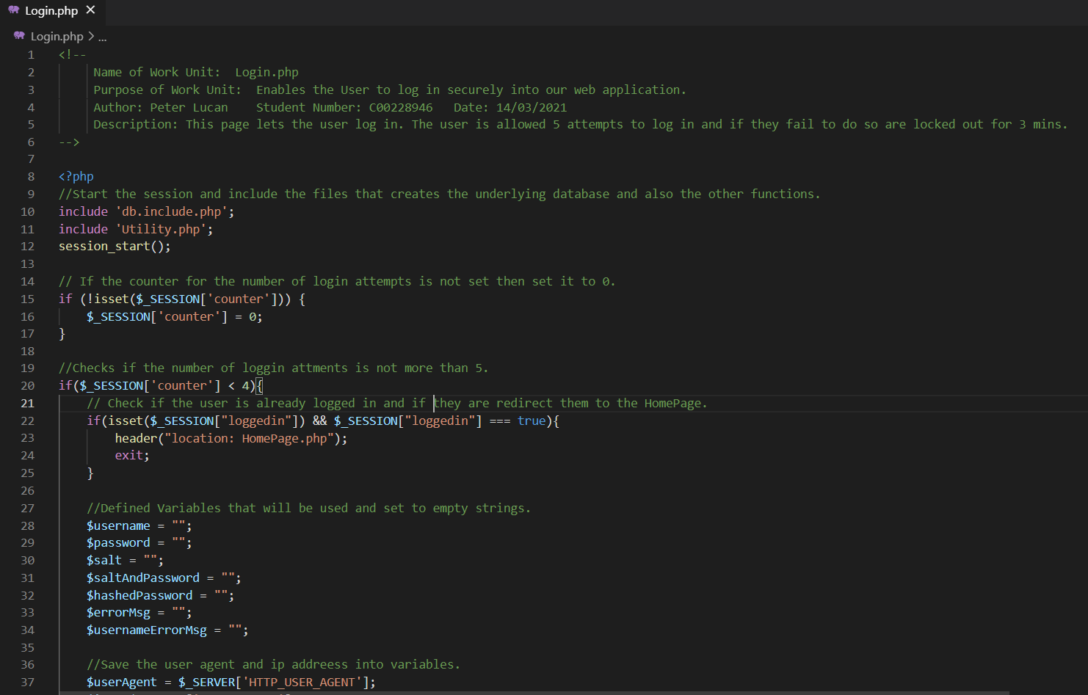

**Figure 50:** Login.php Part 1.

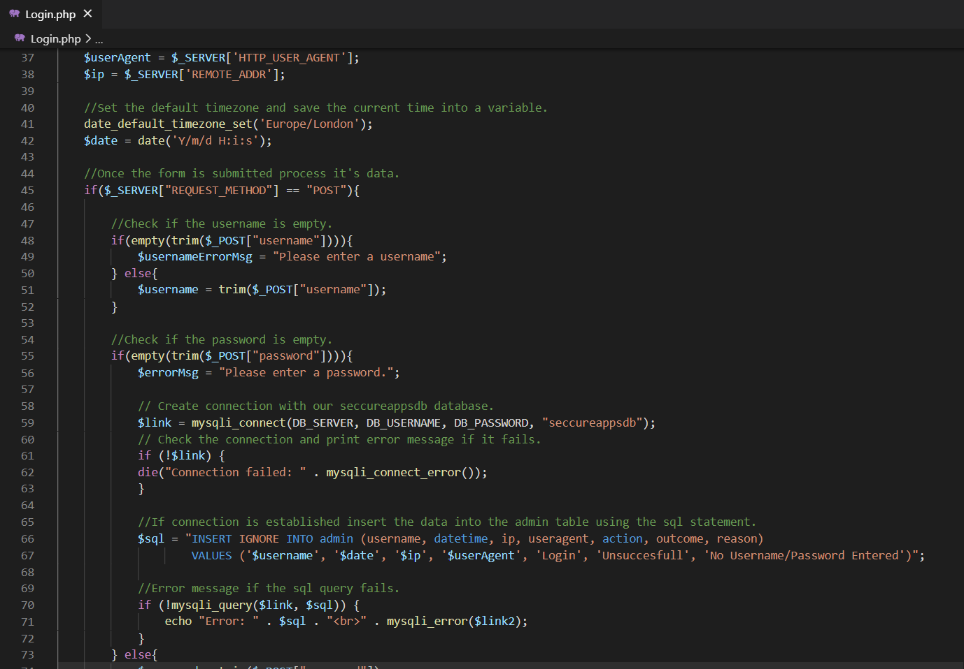

**Figure 51:** Login.php Part 2.

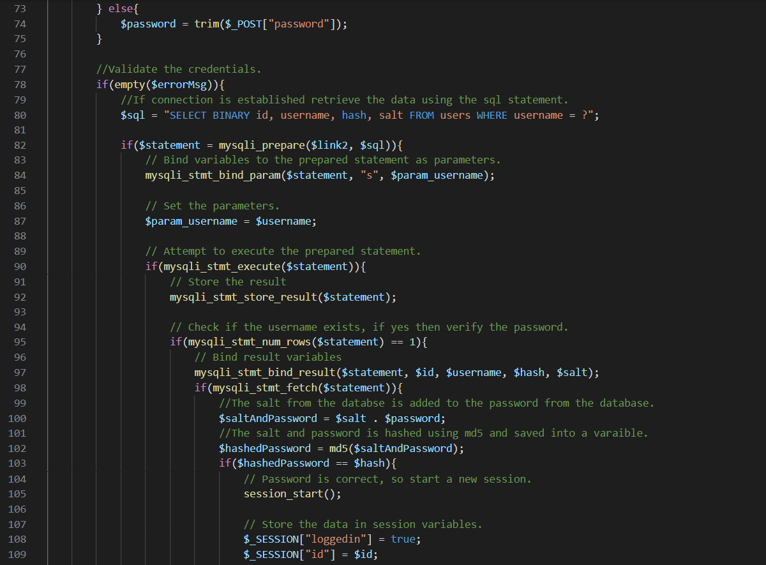

**Figure 52:** Login.php Part 3.

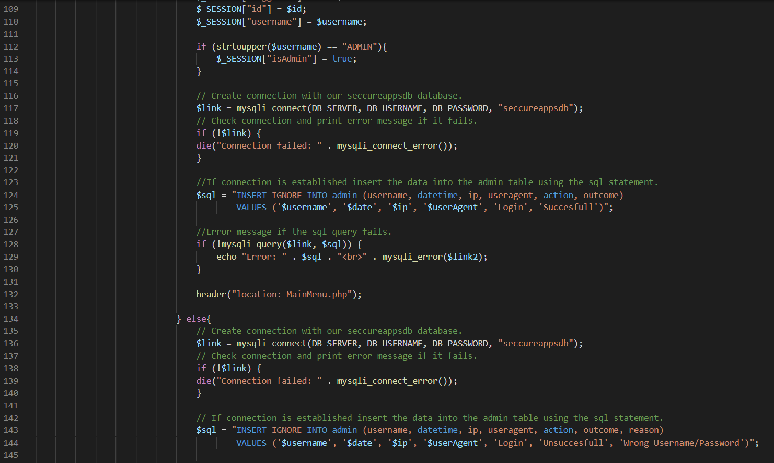

**Figure 53:** Login.php Part 4.

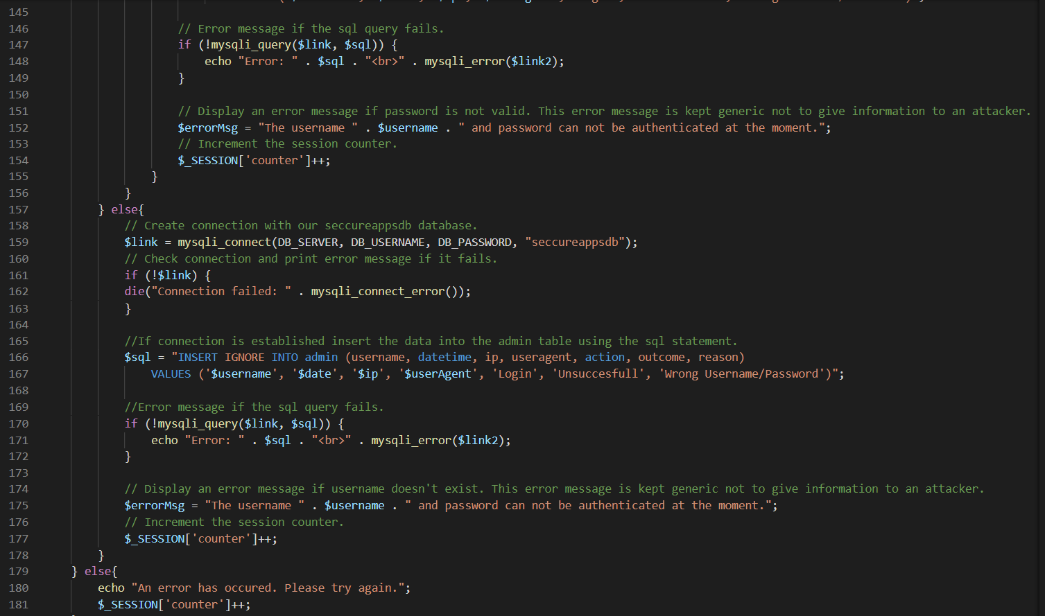

**Figure 54:** Login.php Part 5.

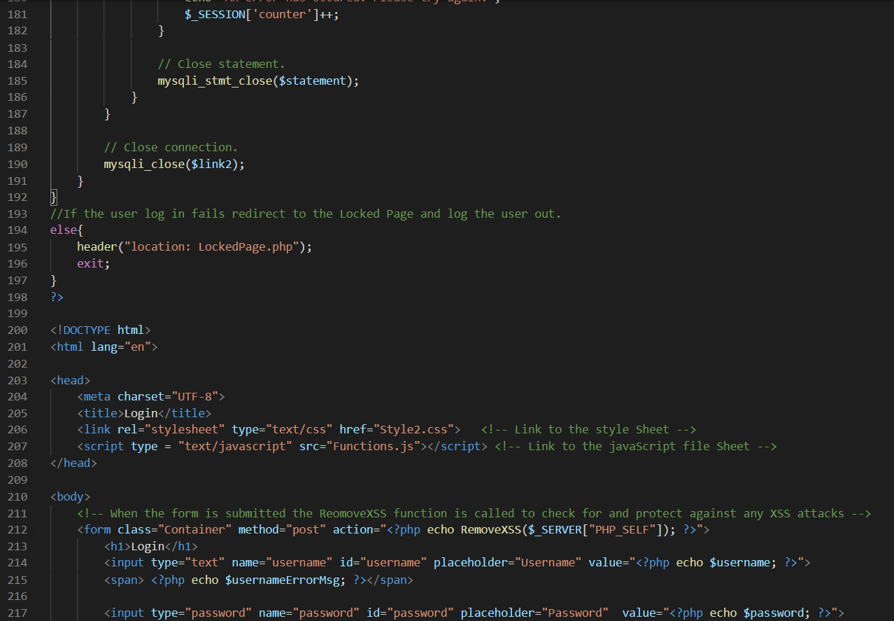

**Figure 55:** Login.php Part 6.

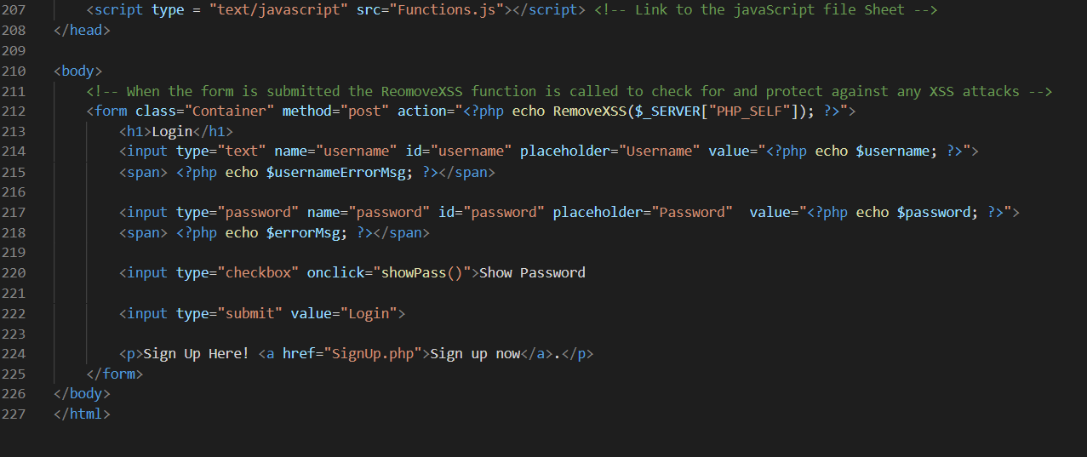

**Figure 56:** Login.php Part 7.

## 3.4 Logging In ( Successful Authentication )

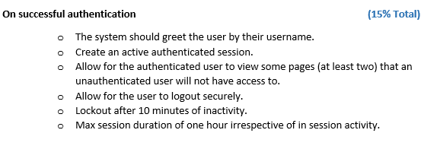

**Figure 57:** Screenshot of the Task From the Specification.

Upon successful login the user is brought to the main menu where they are greeted by their username and an Authenticated Session is created. As previously stated, this menu appears different for the ADMIN. The user now has access to pages that an unauthenticated user does not have access to such as the Home Page, The Profile Page and the Change Password Page. In the case of an ADMIN the ADMIN also has access to the Admin Page and the Secret Records Page. The user can logout securely using the logout button that unsets all session variables and destroys the session. The application also logs out after 10 minutes if inactivity and the application also logs out the user after 60 minutes regardless of activity.



**Figure 58:** Upon Logging Into the Application.

The session is created in the Login.php file displayed in the screenshots of the previous section. The code for how the rest was achieved can be viewed in the screenshots bellow and is explained thoroughly with comments in the code so it does not need further explanation using text in this document. The Maine Menu page includes the aforementioned Utility.php file and links the Style2 and Style3 CSS files. Most of the code is in the MainMenu.php file but it also includes a new file we have not met yet called SessionTime.php which keeps counts time until 1 hour passes and logs the user out regardless of activity.

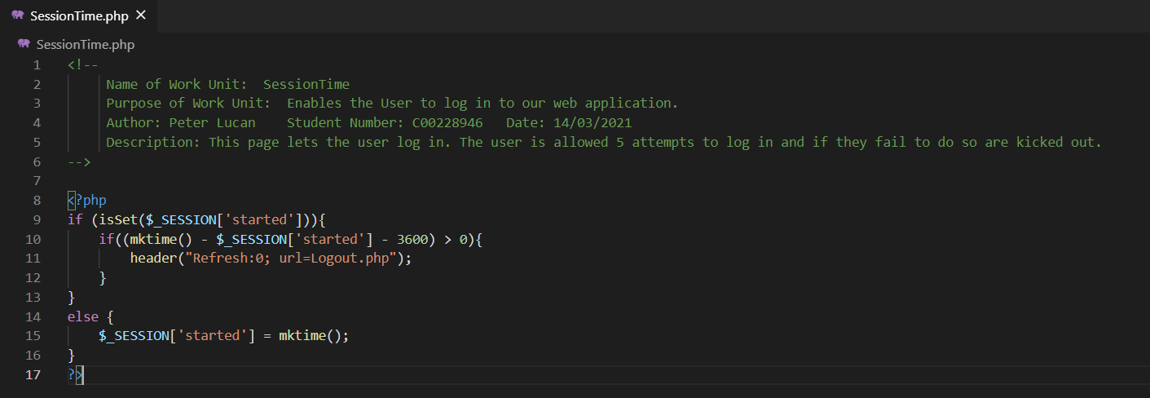

**Figure 59:** SessionTime.php

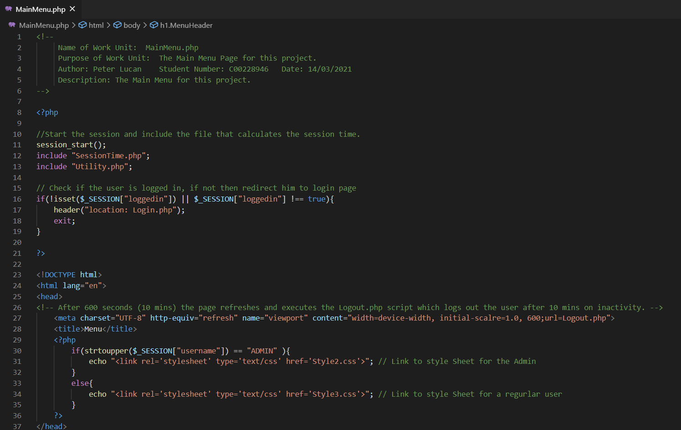

**Figure 60:** MainMenu.php Part 1.

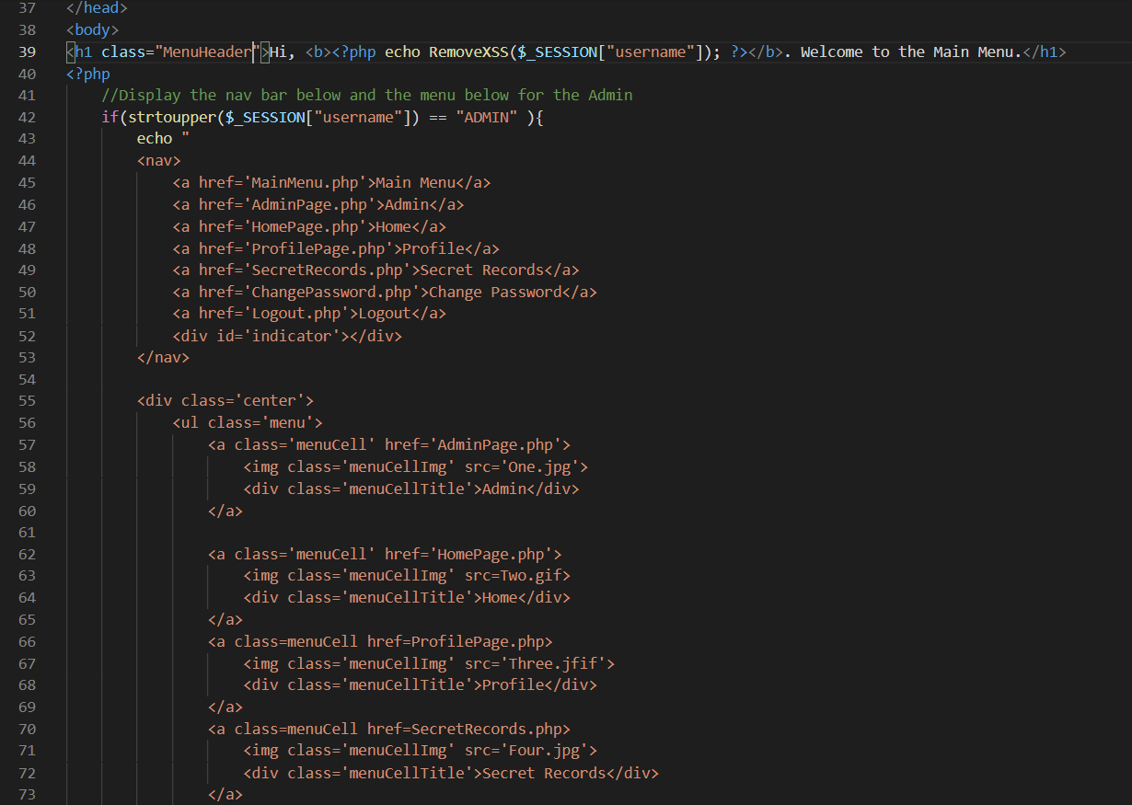

**Figure 61:** MainMenu.php Part 2.

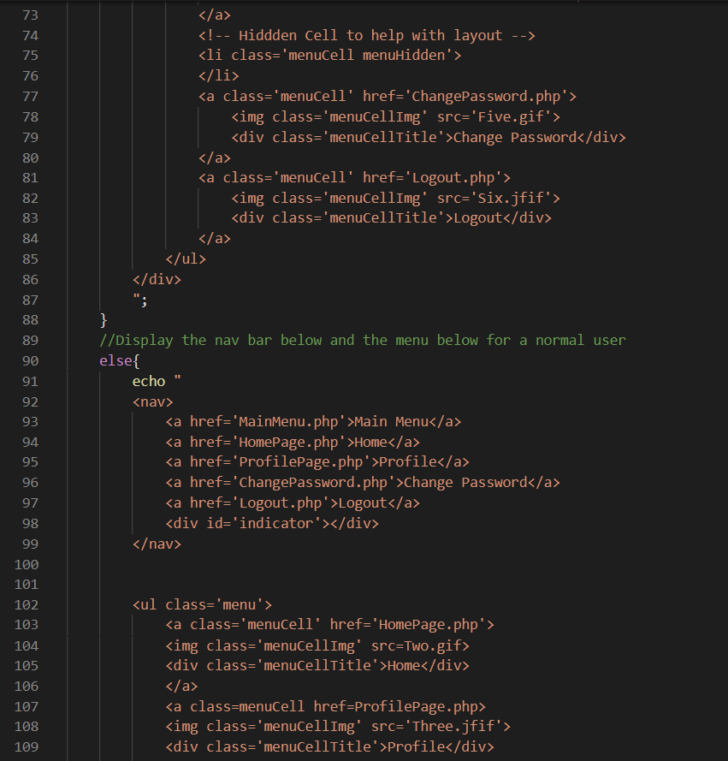

**Figure 62:** MainMenu.php Part 3.

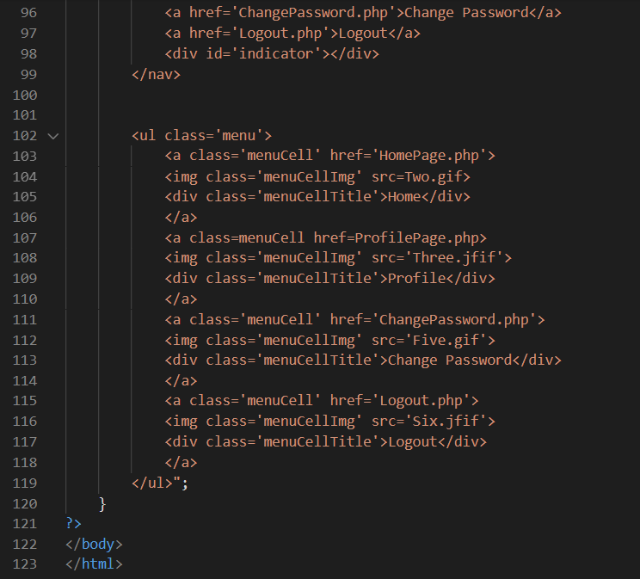

**Figure 63:** MainMenu.php Part 4.

## 3.5 Password Change

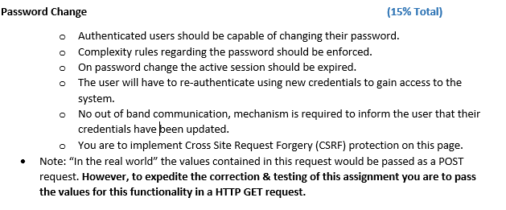

**Figure 64:** Screenshot of the Task From the Specification.

Only Authenticated users can change their password as an unauthenticated user as mentioned before cannot access any of the pages inside of the web application. They are just redirected to the login page. Complexity rules for the password were reused here from the Sign-Up Page. Once the password is changed the user is logged out of the application and redirected to the login page where they have to enter their username and their new password. For this assignment this is done through the GET request. For CSRF protection a token is generated and then that token is stored in a variable. That variable is then submitted using a hidden field in the form. The hash of the generated token is then compared with the hash of the token being sent by the form and if they are the same then the password change may proceed and if not the user is logged out.

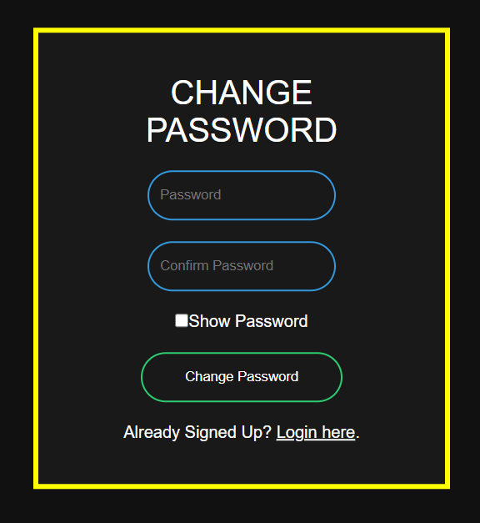

**Figure 65:** Change Password Screen.

The code for how the rest was achieved can be viewed in the screenshots bellow and is explained thoroughly with comments in the code so it does not need further explanation using text in this document. The Change Password page includes the aforementioned Utility.php file, the SessionTime.php file, the db.include.php file and links the Style2 and Style3 CSS files and the Functions.js file. Most of the code is in the ChangePassword.php file but it also includes a new file we have not met yet called CRSF.php which generates the Session Variable.

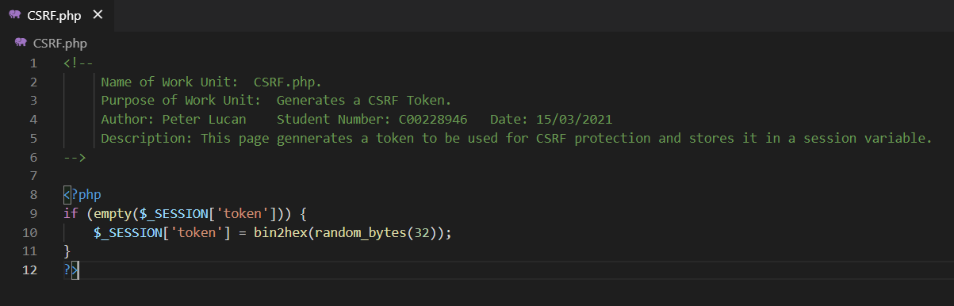

**Figure 66:** CSRF.php File.

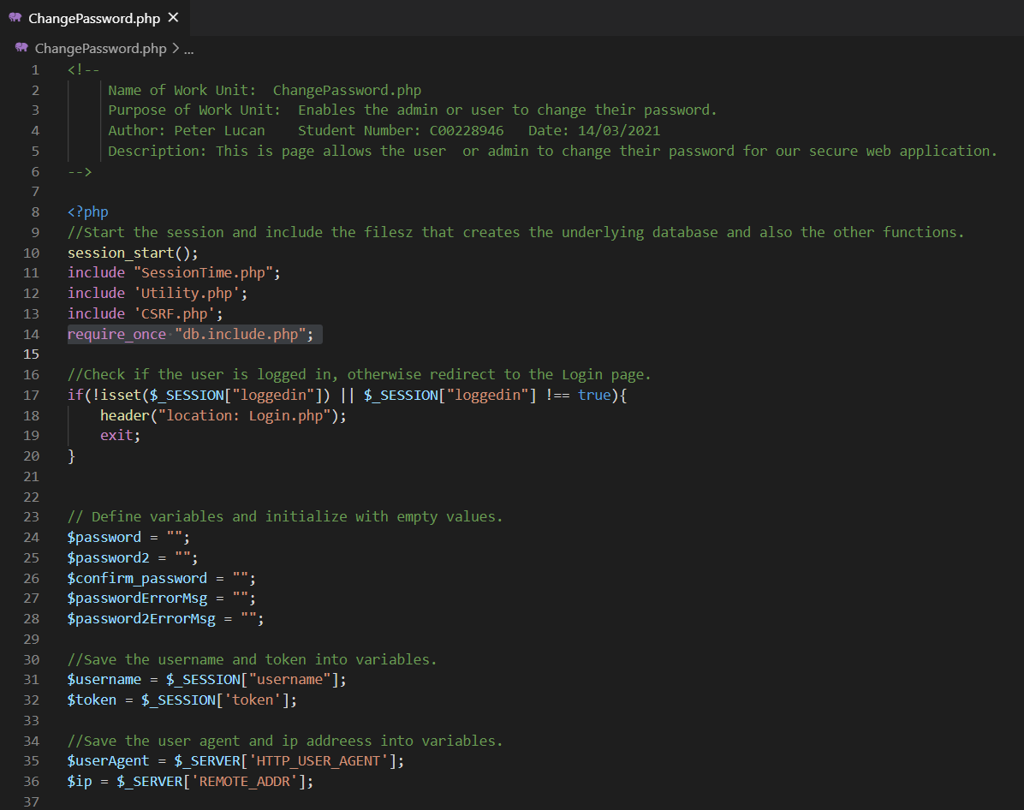

**Figure 67:** ChangePassword.php File Part 1.

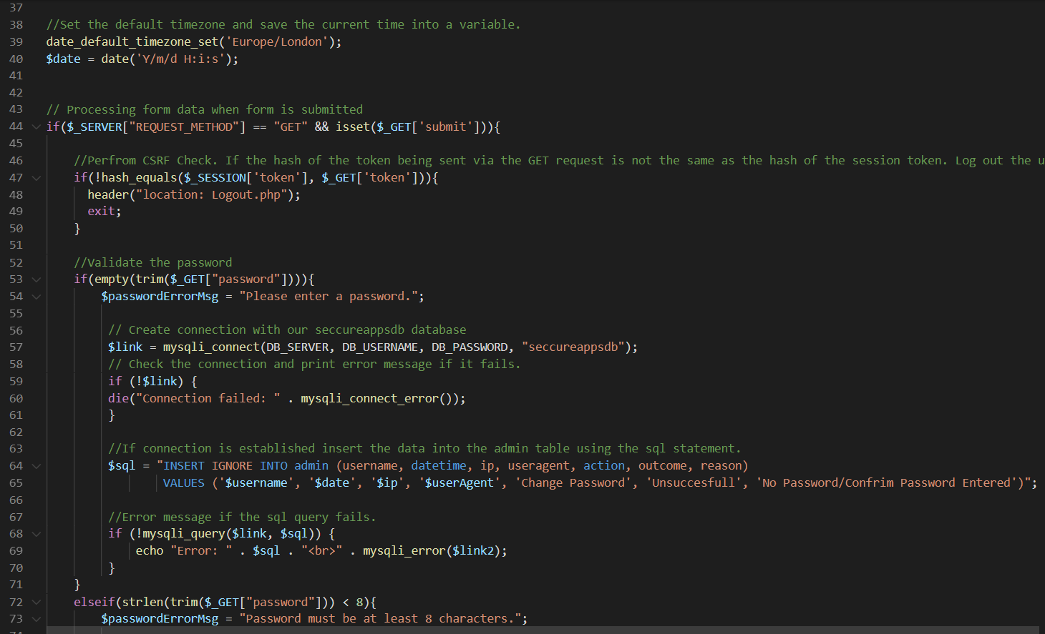

**Figure 68:** ChangePassword.php File Part 2.

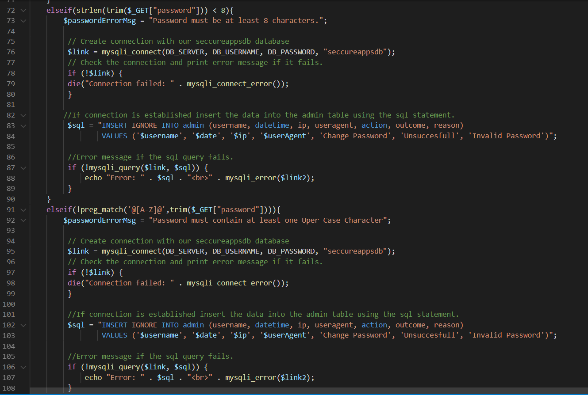

**Figure 69:** ChangePassword.php File Part 3.

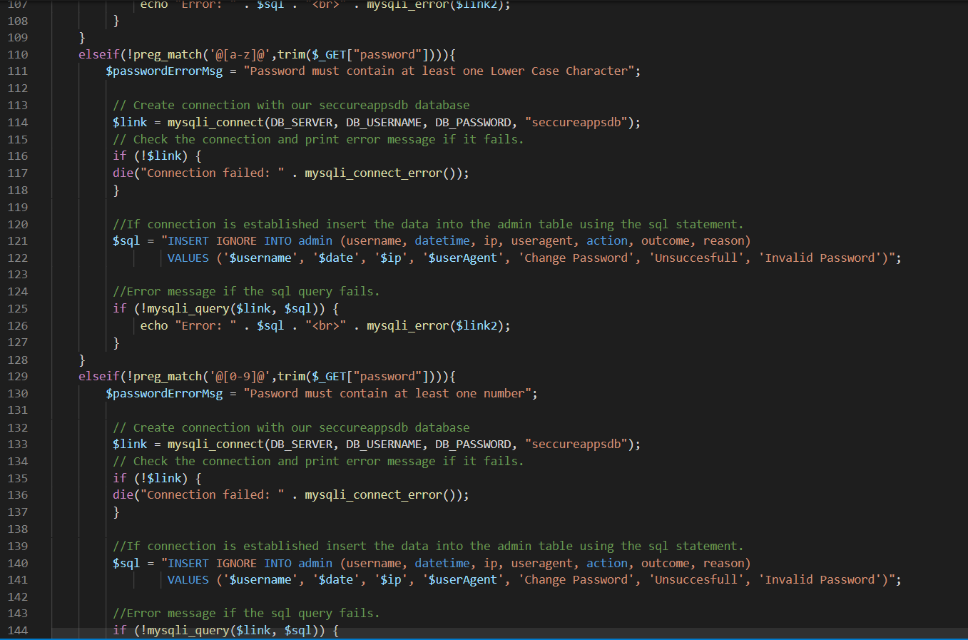

**Figure 70:** ChangePassword.php File Part 4.

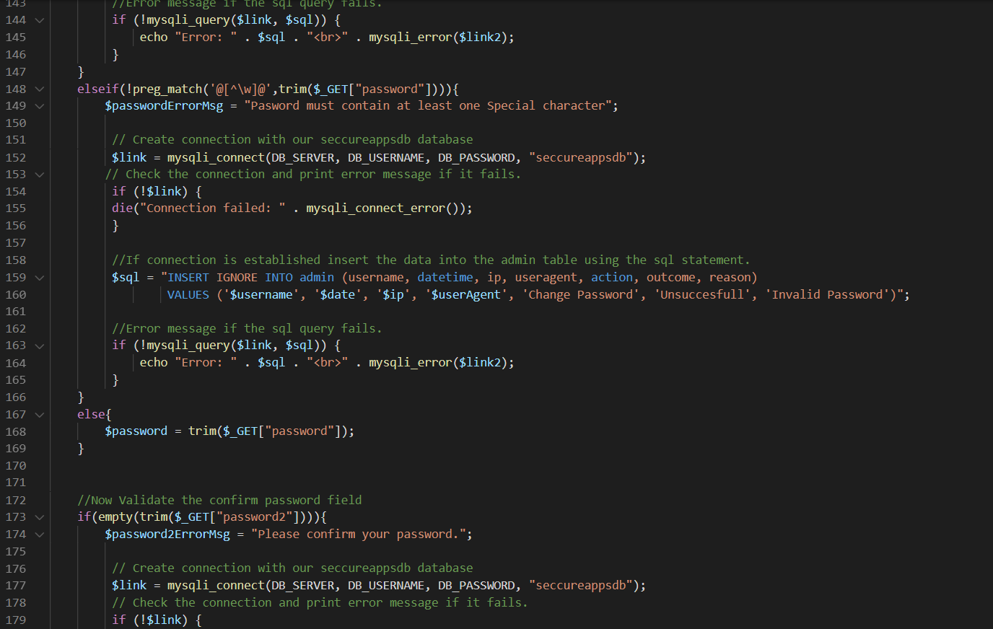

**Figure 71:** ChangePassword.php File Part 5.

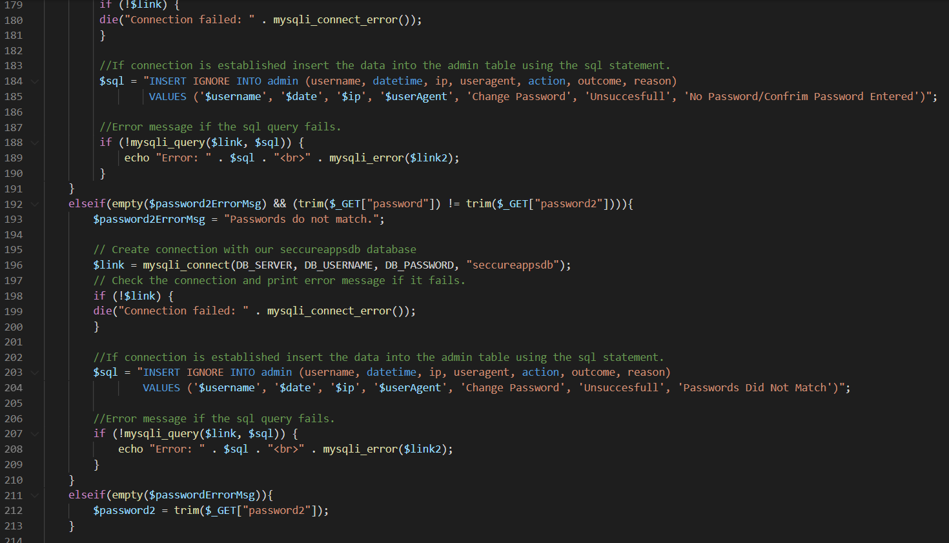

**Figure 72:** ChangePassword.php File Part 6.

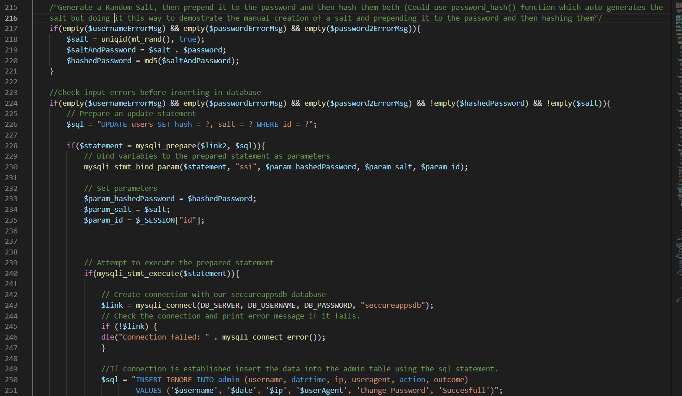

**Figure 73:** ChangePassword.php File Part 7.

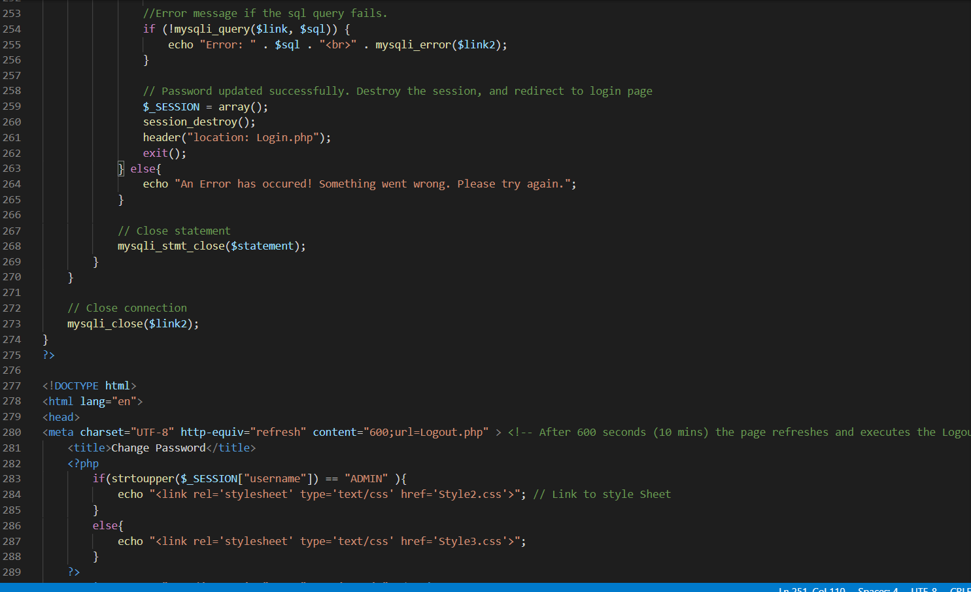

**Figure 74:** ChangePassword.php File Part 8.

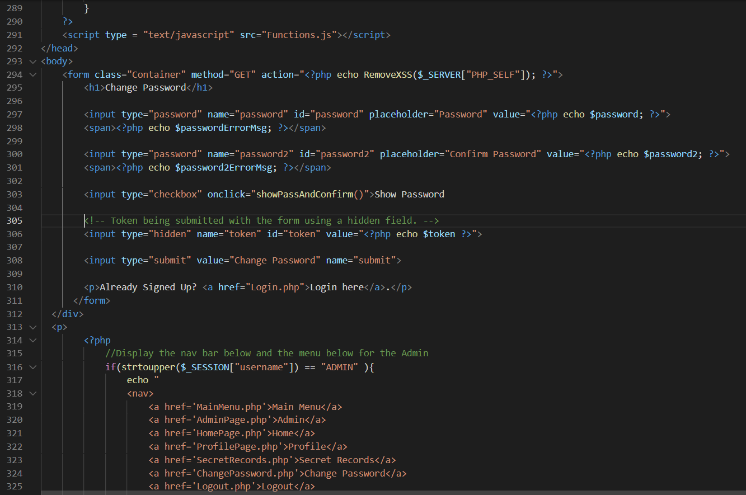

**Figure 75:** ChangePassword.php File Part 9.

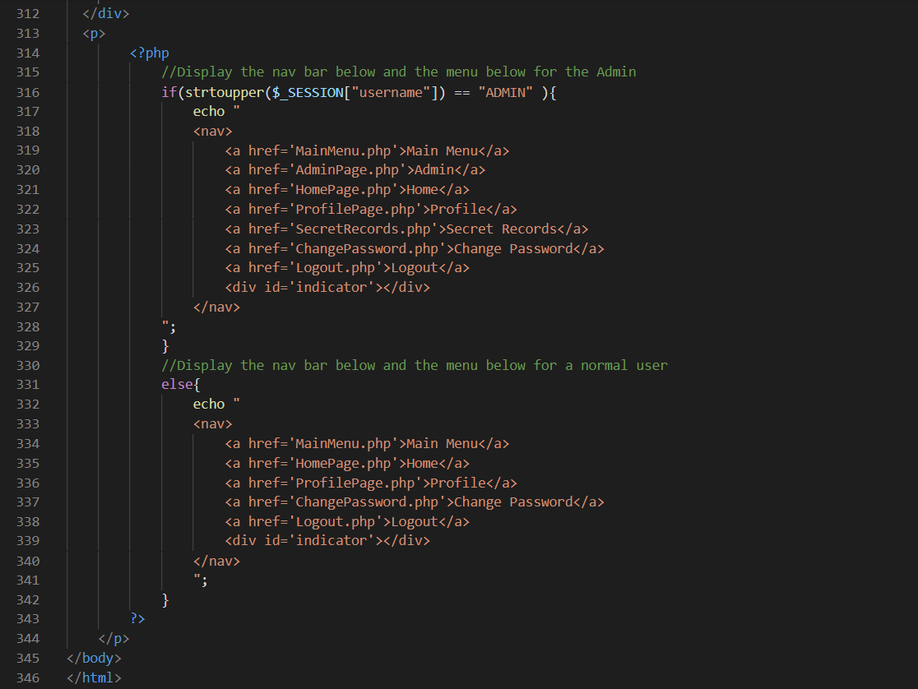

**Figure 76:** ChangePassword.php File Part 10.

## 3.6 Event Log & ADMIN User

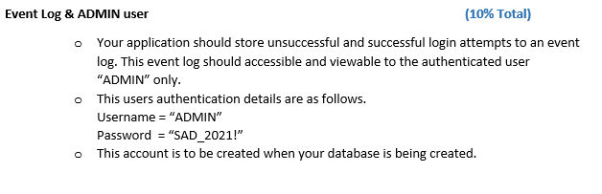

**Figure 77:** Screenshot of the Task From the Specification.

The web application stores all Sign-Up, Login, Change Password and Logout Events whether successful or unsuccessful to an event log and some relevant information to go with it. The event log can seen bellow.

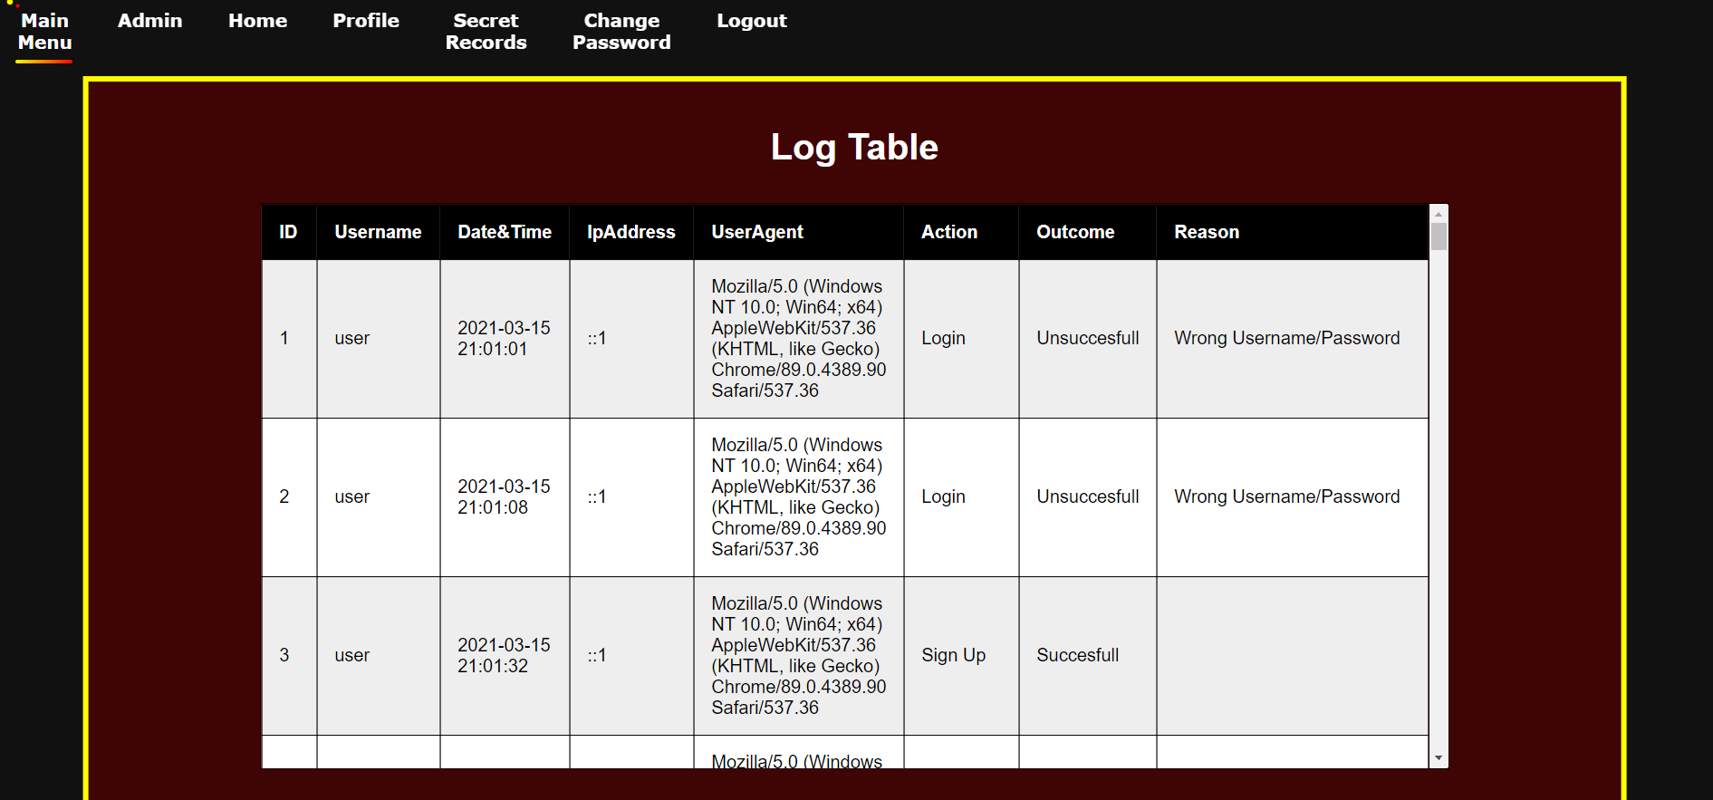

**Figure 78:** The Event Log.

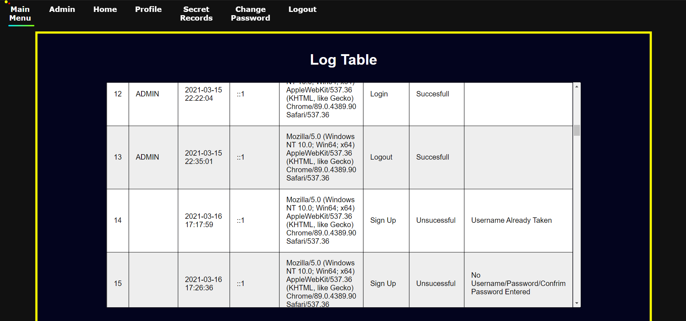

**Figure 79:** The Event Log.

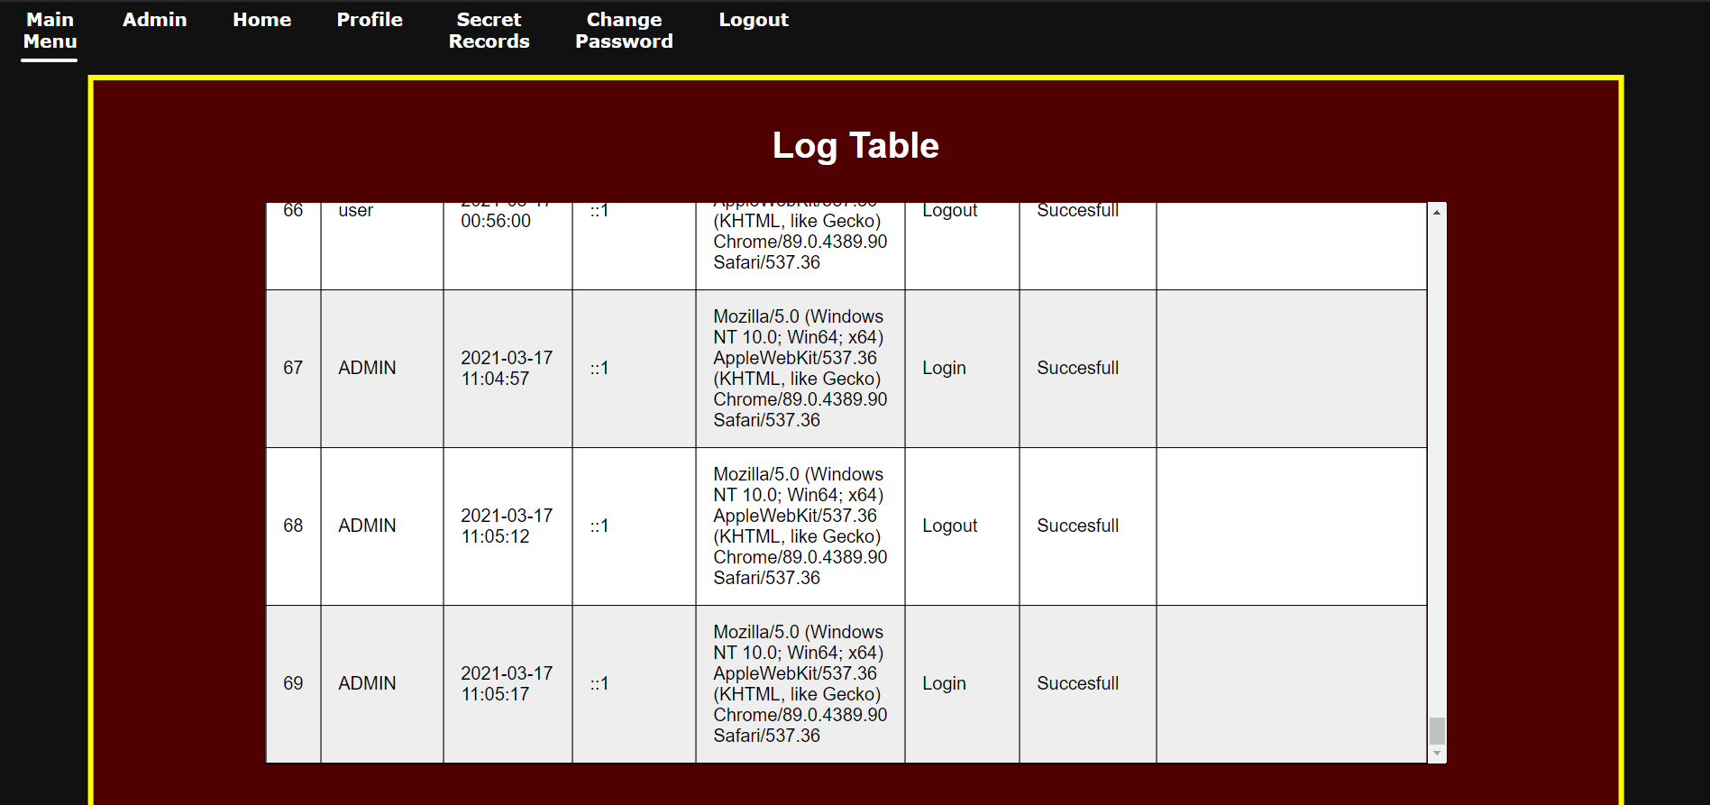

**Figure 80:** The Event Log.

The event log can only be viewed and accessed by the ADMIN just like the Secret Records Page. This is done by checking if the ADMIN is logged in at the top of the file and redirecting to the login page if the ADMIN is not logged in. The Credentials for the ADMIN user are as specified in the specification but the ADMIN is capable of changing their password if they wish. The ADMIN user is created when the Underlying database is created automatically. The data for the ADMIN page is retrieved from the admin database and all the relevant pages store data to the admin page depending on the activity being recorded with a version of the bellow command.

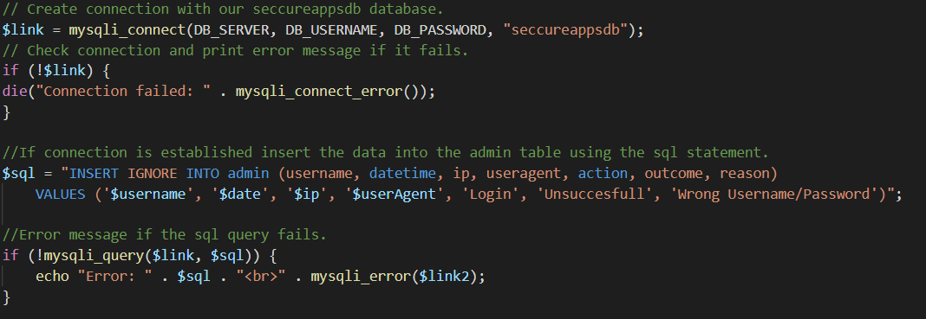

**Figure 81:** Example of Inserting Event Information Into the admin Database.

The code for how this was achieved can be viewed in the screenshots bellow and is explained thoroughly with comments in the code so it does not need further explanation using text in this document. The Admin Page includes the aforementioned the Utility.php file, the SessionTime.php file and the majority of its code is written in the AdminPage.php file. It also links the Style2 and Style3 CSS files.

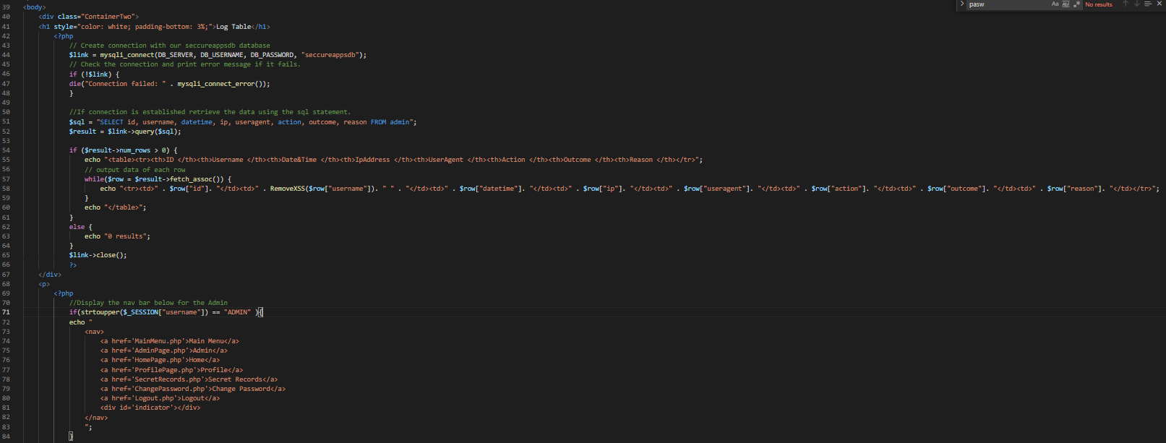

**Figure 82:** AdminPage.php Part 1.



**Figure 83:** AdminPage.php Part 2.

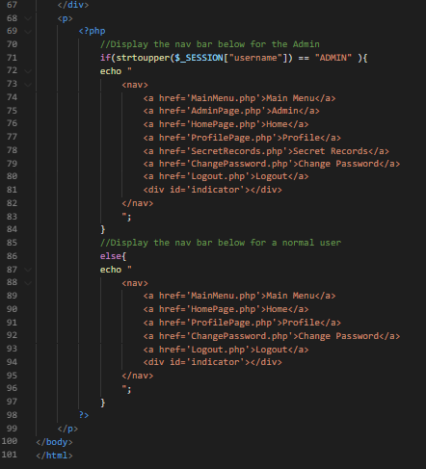

**Figure 84:** AdminPage.php Part 3.

# 4 Security Testing

## 4.1 SignUp.php Testing

### 4.1.1 XSS and SQL Injection Testing

|  |  |  |  |  |  |
| --- | --- | --- | --- | --- | --- |
| ID | Action | Inputs | Expected Results | Actual Result | Test Result |
| 1 | Input Valid Username, Password and a XSS command for Confirm Password | Username: user  Password: qqWW11””  Confirm Password: <script>alert(“hi”)</script> | Passwords do not match | Passwords do not match | Pass |
| 2 | Input Valid Username and a XSS command for Password and Confirm Password | Username: user  Password: <script>alert(“hi”)</script>  Confirm Password: <script>alert(“hi”)</script> | Password must contain at least one Upper Case Character | Password must contain at least one Upper Case Character | Pass |
| 3 | Input Valid Username and a XSS command for Password and Confirm Password that passes password strength checks. | Username: user  Password: <Script>alert(“hi8”)</Script>  Confirm Password: <Script>alert(“hi8”)</Script> | Characters Escaped and password was hashed with a salt and stored in the database. | Characters Escaped and password was hashed with a salt and stored in the database | Pass |
| 4 | Login using credentials from previous test case. | Username: user  Password: <Script>alert(“hi8”)</Script> | Login Successful | Login Successful | Pass |
| 5 | Input XSS commands for all fields passes password strength checks. | Username: <Script>alert(“hi8”)</Script>  Password: <Script>alert(“hi8”)</Script>  Confirm Password: <Script>alert(“hi8”)</Script> | Characters Escaped and password was hashed with a salt and stored in the database. | Characters Escaped and password was hashed with a salt and stored in the database. | Pass |
| 6 | Login using credentials from previous test case. | Username: <Script>alert(“hi8”)</Script>  Password: <Script>alert(“hi8”)</Script>  Confirm Password: <Script>alert(“hi8”)</Script> | Login Successful | Login Successful | Pass |
| 7 | SQL Injection Based on 1=1 is Always True | Look for a way to access input the user ID | No way to input the user ID manually | No way to input the user ID manually | Pass |
| 8 | SQL Injection Based on ""="" is Always True for all fields | Username: " or ""="  Password: " or ""="  Confirm Password: " or ""=" | Prevented due to password complexity rules | Prevented due to password complexity rules | Pass |
| 9 | SQL Injection Based on ""="" is Always True for username field | Username: " or ""="  Password: qqWW11””  Confirm Password: qqWW11”” | Characters Escaped and password was hashed with a salt and stored in the database. | Characters Escaped and password was hashed with a salt and stored in the database. | Pass |
| 10 | SQL Injection Based on Batched SQL Statements for all fields | Username: 1; DROP TABLE users  Password: 1; DROP TABLE users  Confirm Password: 1; DROP TABLE users | Prevented due to password complexity rules | Prevented due to password complexity rules | Pass |
| 11 | SQL Injection Based on Batched SQL Statements for username field | Username: 1; DROP TABLE users  Password: qqWW11””  Confirm Password: qqWW11”” | Characters Escaped and password was hashed with a salt and stored in the database | Characters Escaped and password was hashed with a salt and stored in the database | Pass |

### 4.1.2 Password and Authentication Testing

|  |  |  |  |  |  |
| --- | --- | --- | --- | --- | --- |
| ID | Action | Inputs | Expected Results | Actual Result | Test Result |
| 12 | No username, password or confirm password | Username: “”  Password: ””  Confirm Password: ”” | Please enter a username, Please enter a password, Please confirm your password | Please enter a username, Please enter a password, Please confirm your password | Pass |
| 13 | No password or confirm password | Username: aa  Password: ””  Confirm Password: ”” | Please enter a password, Please confirm your password | Please enter a password, Please confirm your password | Pass |
| 14 | No confirm password | Username: “aa  Password: qqWW11””  Confirm Password: ”” | Please confirm your password | Please confirm your password | Pass |
| 15 | Password and Confirm Password not matching | Username: “aa  Password: qqWW11””  Confirm Password: qqWW11”””” | Passwords do not match | Passwords do not match | Pass |
| 16 | Password < 8 characters | Username: jj  Password: qqww1$  Confirm Password: qqww1$ | Password must be at least 8 characters. | Password must be at least 8 characters. | Pass |
| 17 | Password with no upper-case letter | Username: jj  Password: qqww11$$  Confirm Password: qqww11$$ | Password must contain at least one Upper Case Character | Password must contain at least one Upper Case Character | Pass |
| 18 | Password with no lower-case letter | Username: jj  Password: QQWW11$$  Confirm Password: QQWW11$$ | Password must contain at least one Lower Case Character | Password must contain at least one Lower Case Character | Pass |
| 19 | Password with no number | Username: jj  Password: QQWWww$$  Confirm Password: QQWWww$$ | Password must contain at least one number | Password must contain at least one number | Pass |
| 20 | Password with no special character | Username: jj  Password: QQWWww11  Confirm Password: QQWWww11 | Password must contain at least one Special character | Password must contain at least one Special character | Pass |
| 21 | Password at least 8 characters in length with at least one special char, number, upper case letter and lower case letter | Username: jj  Password: QQWW££11  Confirm Password: QQWW££11 | Sign up Successful and redirected to the login page | Sign up Successful and redirected to the login page | Pass |
| 22 | Show password functionality | Button unchecked | Password not visible | Password not visible | Pass |
| 23 | Show password functionality | Button checked | Password visible | Password visible | Pass |
| 24 | Salt prepended to password and hashed and both salt and hash stored in db | Username: jj  Password: QQWW££11  Confirm Password: QQWW££11 | Successful | Successful | Pass |

This page does not need authentications.

### 4.1.3 Session Management Testing

This page does not use a session.

### 4.1.1 CSRF Testing

This page does not provide CSRF Protection.

## 4.2 Login.php Testing

### 4.2.1 XSS and SQL Injection Testing

|  |  |  |  |  |  |
| --- | --- | --- | --- | --- | --- |
| ID | Action | Inputs | Expected Results | Actual Result | Test Result |
| 25 | Input Valid Username and a XSS command for the Password | Username: user  Password: <script>alert(“hi”)</script> | The username user and password cannot be authenticated at the moment. | The username user and password cannot be authenticated at the moment. | Pass |
| 26 | Input XSS commands for both fields | Username: <script>alert(“hi”)</script>  Password: <script>alert(“hi”)</script> | The username and password cannot be authenticated at the moment. (Script not reflected back in the message) | The username and password cannot be authenticated at the moment. | Pass |
| 27 | SQL Injection Based on 1=1 is Always True | Look for a way to access input the user ID | No way to input the user ID | No way to input the user ID | Pass |
| 28 | SQL Injection Based on ""="" is Always True for all fields | Username: " or ""="  Password: " or ""=" | he username " or ""=" and password can not be authenticated at the moment. | he username " or ""=" and password can not be authenticated at the moment. | pass |
| 29 | SQL Injection Based on Batched SQL Statements for all fields | Username: 1; DROP TABLE users  Password: 1; DROP TABLE users | The username 1; DROP TABLE users and password can not be authenticated at the moment. | The username 1; DROP TABLE users and password can not be authenticated at the moment. | Pass |

### 4.2.2 Password and Authentication Testing

|  |  |  |  |  |  |
| --- | --- | --- | --- | --- | --- |
| ID | Action | Inputs | Expected Results | Actual Result | Test Result |
| 30 | Enter incorrect credentials 5 times | Username: 1; DROP TABLE users  Password: 1; DROP TABLE users | Locked out and redirected to the locked page for 3 minutes | Locked out and redirected to the locked page for 3 minutes | Pass |
| 31 | Try Access the login page while locked out via the address bar | http://localhost/C00228946/Login.php | Redirected to the locked page | Redirected to the locked page | Pass |

### 4.2.3 Session Management Testing

|  |  |  |  |  |  |
| --- | --- | --- | --- | --- | --- |
| ID | Action | Inputs | Expected Results | Actual Result | Test Result |
| 32 | Start session on successful login | Username:user  Password:qqWW11”” | Session Started | Session Started | Pass |
| 33 | Do not start session on failed login | Username:user  Password:qqWW11 | Session not Started | Session not Started | Pass |
| 34 | Set login session variables on successful login | Username:user  Password:qqWW11”” | Session variables set | Session variables set | Pass |
| 35 | Do not set login session variables on unsuccessful login | Username:user  Password:qqWW11 | Session variables not set | Session variables not set | Pass |
| 36 | Once Logged in the back button does not log you out it loads an error page | Back button | Error page | Error page | Pass |

### 4.2.4 CSRF Testing

This page does not provide CSRF Protection.

## 4.3 MainMenu.php Testing

### 4.3.1 XSS and SQL Injection Testing

|  |  |  |  |  |  |
| --- | --- | --- | --- | --- | --- |
| ID | Action | Inputs | Expected Results | Actual Result | Test Result |
| 37 | Returning a username that is an XSS command | <script>alert(“hi”)</script> | Characters are escaped and the username is returned to the user without the XSS attack executing | Characters are escaped and the username is returned to the user without the XSS attack executing | Pass |

### 4.3.2 Password and Authentication Testing

|  |  |  |  |  |  |
| --- | --- | --- | --- | --- | --- |
| ID | Action | Inputs | Expected Results | Actual Result | Test Result |
| 38 | Trying to view this page via url when not signed in | http://localhost/C00228946/MainMenu.php | Redirected to the login page | Redirected to the login page | Pass |
| 39 | Trying to view this page via url when signed in as user | http://localhost/C00228946/MainMenu.php | Main menu page displayed | Main menu page displayed | Pass |
| 40 | Trying to view this page via url when signed in as admin | http://localhost/C00228946/MainMenu.php | Main menu page displayed | Main menu page displayed | Pass |
| 41 | This page appears when logging is as a user | Username:user  Password:qqWW11”” | Main menu page for regular user is displayed | Main menu page for regular user is displayed | Pass |
| 42 | This page appears when logging is as the admin | Username:ADMIN  Password:SAD_2021! | Main menu page for the admin is displayed | Main menu page for the admin is displayed | Pass |

### 4.3.3 Session Management Testing

|  |  |  |  |  |  |
| --- | --- | --- | --- | --- | --- |
| ID | Action | Inputs | Expected Results | Actual Result | Test Result |
| 43 | Pressing the back button | Back button | Error message displayed | Error message displayed | Pass |
| 44 | Session should expire after 10 mins of inactivity | Wait 10 mins | User logged out and redirected to the login page | User logged out and redirected to the login page | Pass |
| 45 | Session should expire after 60 mins | Wait 60 mins | User logged out and redirected to the login page | User logged out and redirected to the login page | Pass |

### 4.3.4 CSRF Testing

This page does not provide CSRF Protection.

## 4.4 Admin.php Testing

### 4.4.1 XSS and SQL Injection Testing

|  |  |  |  |  |  |
| --- | --- | --- | --- | --- | --- |
| ID | Action | Inputs | Expected Results | Actual Result | Test Result |
| 46 | Returning a username that is an XSS command from the database | <script>alert(“hi”)</script> | Characters are escaped and the username is returned to the user without the XSS attack executing | Characters are escaped and the username is returned to the user without the XSS attack executing | Pass |

### 4.4.2 Password and Authentication Testing

|  |  |  |  |  |  |
| --- | --- | --- | --- | --- | --- |
| ID | Action | Inputs | Expected Results | Actual Result | Test Result |
| 47 | Trying to view this page via url when not signed in | http://localhost/C00228946/AdminPage.php | Redirected to the login page | Redirected to the login page | Pass |
| 48 | Trying to view this page via url when signed in as user | http://localhost/C00228946/ AdminPage.php | Redirected to Home Page | Redirected to Home Page | Pass |
| 49 | Trying to view this page via url when signed in as admin | http://localhost/C00228946/ AdminPage.php | Admin page displayed | Admin page displayed | Pass |
| 50 | Not Possible to navigate to this page when logged in as a user | Username:user  Password:qqWW11”” | Not Possible to navigate to this page when logged in as a user | Not Possible to navigate to this page when logged in as a user | Pass |
| 51 | Possible to navigate to this page when logged in as the admin | Username:ADMIN  Password:SAD_2021! | Possible to navigate to this page when logged in as the admin | Possible to navigate to this page when logged in as the admin | Pass |

### 4.4.3 Session Management Testing

|  |  |  |  |  |  |
| --- | --- | --- | --- | --- | --- |
| ID | Action | Inputs | Expected Results | Actual Result | Test Result |
| 52 | Pressing the back button | Back button | Displays previous page | Displays previous page | Pass |
| 53 | Session should expire after 10 mins of inactivity | Wait 10 mins | User logged out and redirected to the login page | User logged out and redirected to the login page | Pass |
| 54 | Session should expire after 60 mins | Wait 60 mins | User logged out and redirected to the login page | User logged out and redirected to the login page | Pass |

### 4.4.4 CSRF Testing

This page does not provide CSRF Protection.

## 4.5 HomePage.php Testing

### 4.5.1 XSS and SQL Injection Testing

|  |  |  |  |  |  |
| --- | --- | --- | --- | --- | --- |
| ID | Action | Inputs | Expected Results | Actual Result | Test Result |
| 55 | Returning a username that is an XSS command | <script>alert(“hi”)</script> | Characters are escaped and the username is returned to the user without the XSS attack executing | Characters are escaped and the username is returned to the user without the XSS attack executing | Pass |

### 4.5.2 Password and Authentication Testing

|  |  |  |  |  |  |
| --- | --- | --- | --- | --- | --- |
| ID | Action | Inputs | Expected Results | Actual Result | Test Result |
| 56 | Trying to view this page via url when not signed in | http://localhost/C00228946/HomePage.php | Redirected to the login page | Redirected to the login page | Pass |
| 57 | Trying to view this page via url when signed in as user | http://localhost/C00228946/ HomePage.php | Home page displayed | Home page displayed | Pass |
| 58 | Trying to view this page via url when signed in as admin | http://localhost/C00228946/ HomePage.php | Home page displayed | Home page displayed | Pass |
| 59 | Not Possible to navigate to this page when logged in as a user | Username:user  Password:qqWW11”” | Not Possible to navigate to this page when logged in as a user | Not Possible to navigate to this page when logged in as a user | Pass |
| 60 | Possible to navigate to this page when logged in as the admin | Username:ADMIN  Password:SAD_2021! | Possible to navigate to this page when logged in as the admin | Possible to navigate to this page when logged in as the admin | Pass |

### 4.5.3 Session Management Testing

|  |  |  |  |  |  |
| --- | --- | --- | --- | --- | --- |
| ID | Action | Inputs | Expected Results | Actual Result | Test Result |
| 61 | Pressing the back button | Back button | Displays previous page | Displays previous page | Pass |
| 62 | Session should expire after 10 mins of inactivity | Wait 10 mins | User logged out and redirected to the login page | User logged out and redirected to the login page | Pass |
| 63 | Session should expire after 60 mins | Wait 60 mins | User logged out and redirected to the login page | User logged out and redirected to the login page | Pass |

### 4.5.4 CSRF Testing

This page does not provide CSRF Protection.

## 4.6 ProfilePage.php Testing

### 4.6.1 XSS and SQL Injection Testing

|  |  |  |  |  |  |
| --- | --- | --- | --- | --- | --- |
| ID | Action | Inputs | Expected Results | Actual Result | Test Result |
|  | Returning a username that is an XSS command | <script>alert(“hi”)</script> | Characters are escaped and the username is returned to the user without the XSS attack executing | Characters are escaped and the username is returned to the user without the XSS attack executing | Pass |

### 4.6.2 Password and Authentication Testing

|  |  |  |  |  |  |
| --- | --- | --- | --- | --- | --- |
| ID | Action | Inputs | Expected Results | Actual Result | Test Result |
| 70 | Trying to view this page via url when not signed in | http://localhost/C00228946/ProfilePage.php | Redirected to the login page | Redirected to the login page | Pass |
| 71 | Trying to view this page via url when signed in as user | http://localhost/C00228946/ ProfilePage.php | Profile page displayed | Profile page displayed | Pass |
| 72 | Trying to view this page via url when signed in as admin | http://localhost/C00228946/ ProfilePage.php | Profile page displayed | Profile page displayed | Pass |
| 73 | Possible to navigate to this page when logged in as a user | Username:user  Password:qqWW11”” | Possible to navigate to this page when logged in as a user | Possible to navigate to this page when logged in as a user | Pass |
| 74 | Possible to navigate to this page when logged in as the admin | Username:ADMIN  Password:SAD_2021! | Possible to navigate to this page when logged in as the admin | Possible to navigate to this page when logged in as the admin | Pass |

### 4.6.3 Session Management Testing

|  |  |  |  |  |  |
| --- | --- | --- | --- | --- | --- |
| ID | Action | Inputs | Expected Results | Actual Result | Test Result |
| 75 | Pressing the back button | Back button | Displays previous page | Displays previous page | Pass |
| 76 | Session should expire after 10 mins of inactivity | Wait 10 mins | User logged out and redirected to the login page | User logged out and redirected to the login page | Pass |
| 77 | Session should expire after 60 mins | Wait 60 mins | User logged out and redirected to the login page | User logged out and redirected to the login page | Pass |

### 4.6.4 CSRF Testing

This page does not provide CSRF Protection.

## 4.7 SecretRecords.php Testing

### 4.7.1 XSS and SQL Injection Testing

|  |  |  |  |  |  |
| --- | --- | --- | --- | --- | --- |
| ID | Action | Inputs | Expected Results | Actual Result | Test Result |
| 78 | Returning a username that is an XSS command | <script>alert(“hi”)</script> | Characters are escaped and the username is returned to the user without the XSS attack executing | Characters are escaped and the username is returned to the user without the XSS attack executing | Pass |

### 4.7.2 Password and Authentication Testing

|  |  |  |  |  |  |
| --- | --- | --- | --- | --- | --- |
| ID | Action | Inputs | Expected Results | Actual Result | Test Result |
| 79 | Trying to view this page via url when not signed in | http://localhost/C00228946/ SecretRecords.php | Redirected to the login page | Redirected to the login page | Pass |
| 80 | Trying to view this page via url when signed in as user | http://localhost/C00228946/ SecretRecords.php | Redirected to Home Page | Redirected to Home Page | Pass |
| 81 | Trying to view this page via url when signed in as admin | http://localhost/C00228946/ SecretRecords.php | Secret Records Page displayed | Secret Records Page displayed | Pass |
| 82 | Not Possible to navigate to this page when logged in as a user | Username:user  Password:qqWW11”” | Not Possible to navigate to this page when logged in as a user | Not Possible to navigate to this page when logged in as a user | Pass |
| 83 | Possible to navigate to this page when logged in as the admin | Username:ADMIN  Password:SAD_2021! | Possible to navigate to this page when logged in as the admin | Possible to navigate to this page when logged in as the admin | Pass |

### 4.7.3 Session Management Testing

|  |  |  |  |  |  |
| --- | --- | --- | --- | --- | --- |
| ID | Action | Inputs | Expected Results | Actual Result | Test Result |
| 84 | Pressing the back button | Back button | Displays previous page | Displays previous page | Pass |
| 85 | Session should expire after 10 mins of inactivity | Wait 10 mins | User logged out and redirected to the login page | User logged out and redirected to the login page | Pass |
| 86 | Session should expire after 60 mins | Wait 60 mins | User logged out and redirected to the login page | User logged out and redirected to the login page | Pass |

### 4.7.4 CSRF Testing

This page does not provide CSRF Protection.

## 4.8 ChangePassword.php Testing

### 4.8.1 XSS and SQL Injection Testing

|  |  |  |  |  |  |
| --- | --- | --- | --- | --- | --- |
| ID | Action | Inputs | Expected Results | Actual Result | Test Result |
| 87 | Input Valid Password and a XSS command for confirm password | Password: 11””qqEE  Confirm Password: <script>alert(“hi”)</script> | Passwords do not match | Passwords do not match | Pass |
| 88 | Input XSS command for Password and for confirm password | Password: <script>alert(“hi”)</script>  Confirm Password: <script>alert(“hi”)</script> | Characters are escaped and the password is saved into the db without the XSS attack executing | Characters are escaped and the password is saved into the db without the XSS attack executing | Pass |
| 89 | SQL Injection Based on 1=1 is Always True | Look for a way to access input the user ID | No way to input the user ID | No way to input the user ID | Pass |
| 90 | SQL Injection Based on ""="" is Always True for all fields | Password: " or ""="  Confirm Password: " or ""=" | Characters are escaped and the password is saved into the db without the XSS attack executing | Characters are escaped and the password is saved into the db without the XSS attack executing | Pass |
| 91 | SQL Injection Based on Batched SQL Statements for all fields | Password: 1; DROP TABLE users  Confirm Password: 1; DROP TABLE users | Characters are escaped and the password is saved into the db without the XSS attack executing | Characters are escaped and the password is saved into the db without the XSS attack executing | Pass |

### 4.8.2 Password and Authentication Testing

|  |  |  |  |  |  |
| --- | --- | --- | --- | --- | --- |
| ID | Action | Inputs | Expected Results | Actual Result | Test Result |
| 92 | No password or confirm password | Password: ””  Confirm Password: ”” | Please enter a password, Please confirm your password | Please enter a password, Please confirm your password | Pass |
| 93 | No confirm password | Password: qqWW11””  Confirm Password: ”” | Please confirm your password | Please confirm your password | Pass |
| 94 | Password and Confirm Password not matching | Password: qqWW11””  Confirm Password: qqWW11”””” | Passwords do not match | Passwords do not match | Pass |
| 95 | Password < 8 characters | Password: qqww1$  Confirm Password: qqww1$ | Password must be at least 8 characters. | Password must be at least 8 characters. | Pass |
| 96 | Password with no upper-case letter | Password: qqww11$$  Confirm Password: qqww11$$ | Password must contain at least one Upper Case Character | Password must contain at least one Upper Case Character | Pass |
| 97 | Password with no lower-case letter | Password: QQWW11$$  Confirm Password: QQWW11$$ | Password must contain at least one Lower Case Character | Password must contain at least one Lower Case Character | Pass |
| 98 | Password with no number | Password: QQWWww$$  Confirm Password: QQWWww$$ | Password must contain at least one number | Password must contain at least one number | Pass |
| 99 | Password with no special character | Password: QQWWww11  Confirm Password: QQWWww11 | Password must contain at least one Special character | Password must contain at least one Special character | Pass |
| 100 | Password at least 8 characters in length with at least one special char, number, upper case letter and lower case letter | Password: QQWW££11  Confirm Password: QQWW££11 | Password Change Successful and redirected to the login page | Password Change Successful and redirected to the login page | Pass |
| 101 | Show password functionality | Button unchecked | Password not visible | Password not visible | Pass |
| 102 | Show password functionality | Button checked | Password visible | Password visible | Pass |
| 103 | Salt prepended to password and hashed and both salt and hash stored in db | Password: QQWW££11  Confirm Password: QQWW££11 | Successful | Successful | Pass |

### 4.8.3 Session Management Testing

|  |  |  |  |  |  |
| --- | --- | --- | --- | --- | --- |
| ID | Action | Inputs | Expected Results | Actual Result | Test Result |
| 104 | Pressing the back button | Back button | Displays previous page | Displays previous page | Pass |
| 105 | Session should expire after 10 mins of inactivity | Wait 10 mins | User logged out and redirected to the login page | User logged out and redirected to the login page | Pass |
| 106 | Session should expire after 60 mins | Wait 60 mins | User logged out and redirected to the login page | User logged out and redirected to the login page | Pass |
| 107 | Pressing back button on successful password change | Back button | Previous session is destroyed and the user is redirected to the login page | Previous session is destroyed and the user is redirected to the login page | Pass |
| 108 | User logged out on successful password change |  | User logged out and redirected to the login page and session destroyed and all session variables reset. | User logged out and redirected to the login page and session destroyed and all session variables reset. | Pass |

### 4.8.4 CSRF Testing

|  |  |  |  |  |  |
| --- | --- | --- | --- | --- | --- |
| ID | Action | Inputs | Expected Results | Actual Result | Test Result |
| 109 | Try submitting the form with mismatching tokens |  | Password not changed and user is logged out | Password not changed and user is logged out | Pass |
| 110 | Submit the form with the correct tokens |  | Password Changed successfully and the user is logged out and redirected to the login page | Password Changed successfully and the user is logged out and redirected to the login page | Pass |

## 4.9 Logout.php Testing

### 4.9.1 XSS and SQL Injection Testing

Not needed for this.

### 4.9.2 Password and Authentication Testing

Not needed for this.

### 4.9.3 Session Management Testing

|  |  |  |  |  |  |
| --- | --- | --- | --- | --- | --- |
| ID | Action | Inputs | Expected Results | Actual Result | Test Result |
| 111 | Logging out | Click the Logout option | User is logged out and redirected to the login page and the session is destroyed and all session variables unset | User is logged out and redirected to the login page and the session is destroyed and all session variables unset | Pass |

### 4.9.4 CSRF Testing

This page does not provide CSRF Protection.

# 5 Conclusion

In conclusion, the web application was built completely following the specification with added CSS to make it visually appealing. As a result, this project can be seen as a great success. During doing this project I have learned a lot about Web Development and Secure Applications Development as I feel that I have built a good product. Due to this I enjoyed working on this project as I have learned a great deal and it has been enjoyable so I have also done some extra work on it. Knowledge of Php and CSS has greatly improved during this project as well as Secure App Development Practices and how to test for and develop such applications.